**Student Assessment Submission and Declaration**

When submitting evidence for assessment, each student must sign a declaration confirming that the work is their own.

|  |  |  |  |
| --- | --- | --- | --- |
| Student name: Vajresh Patkar | | Assessor name: Aniket | |
| Issue date: 3 Jul 2019 | Submission date: 24 Jul 19 | | Submitted on: |
| Programme: Pearson BTEC Level 5 HND in Application Development | | | |
| Unit: 4 Web Design and Development | | | |
| Assignment number and title: 1 of 2: Development of website for a Training Organization – Part 1 | | | |

**Plagiarism**

Plagiarism is a particular form of cheating. Plagiarism must be avoided at all costs and students who break the rules, however innocently, may be penalised. It is your responsibility to ensure that you understand correct referencing practices. As a university level student, you are expected to use appropriate references throughout and keep carefully detailed notes of all your sources of materials for material you have used in your work, including any material downloaded from the Internet. Please consult the relevant unit lecturer or your course tutor if you need any further advice.

**Student Declaration**

|  |
| --- |
| **Student declaration**  I certify that the assignment submission is entirely my own work and I fully understand the consequences of plagiarism. I understand that making a false declaration is a form of malpractice.  Student signature: nhwksh Date: |

Table of Contents

1. Website Requirements 4

❖ Intro 4

❖ User Requirements 4

❖ List all the Pages 5

❖ Information Architecture 5

❖ Wire-frames 6

❖ Storyboard 17

2. Website Design Guidelines and Standards 18

❖ Intro 18

❖ Plan 18

❖ Hosted Website 19

3. Website Testing 32

❖ Intro 32

❖ Testing Approach 32

❖ Test cases 33

❖ Tabular Format 40

4. Design and Output 42

❖ Intro 42

❖ Understanding Design 43

5. Quality Assurance 46

❖ Intro 46

❖ PDCA 46

❖ Tabular view 47

6. Technical Challenges 49

❖ Intro 49

❖ Challenges I Faced 49

7. Test Reviews 56

❖ Intro 56

❖ Passed Test Cases 56

❖ Tests that need improvements 58

❖ Tabular View 60

8. Bibliography 62

# Website Requirements

## Intro

The first step when making a website is to analyse its purpose and its requirements. This helps to give it a reason for its development and makes all the next steps easy. It can be features, pages, content and functionality that should be available to the user. This helps to prioritize the steps and make a **minimum viable product(MVP)**.

There are several ways to distinguish the requirements documents. Most general are **business requirements, user requirements, implementation requirements, functional requirements, quality of service requirements,** etc.

Since ABC Learning Center asked me to develop website to showcase their courses and want the users to enroll in the courses, it is user driven website. So I can start by gathering the user requirements

## User Requirements

User requirements is the description of how the user interacts with the website, what will be their expectations, how they can use the features, functions and content. Reasons why user comes to your site, what will they receive comes in user requirements.

Some of the questions that needs to answered in this requirements are

1. **Who is the user?**

The user ABC Learning Center is looking are **passionate learners** from any age group. But most preferred are between the age 15 to 30 since they will benefit the most from the site.

1. **Why does user comes to the site?**

The main goal of the website is to offer courses to the user from which they can **enhance their skills**. Once they enroll in specific courses, they must have access to 24/7 ask questions from anywhere.

1. **What goals does they have?**

Users will be looking for the courses which are **unique** and which will help them to **gain the skills** they desire in **short amount** of time and money.

1. **How can we serve and make the site easy to consume?**

User should have nice experience when surfing through the website. **Navigation** and **accessibility** should be easy. **Multiple courses** should be available to choose from, **rating** to the courses to shortlist the best one and lastly **testimonies** of other learners to validate the courses. This will all result is great experience to the user and will make it more likely to come back to the website again.

## List all the Pages

Lets finalize all the pages that will be required for the website. This helps to divide the website into pages and develop it one by one. All the pages that are required are

1. Home Page
2. Registration Page
3. Thank You page
4. About Us
5. Contact Us
6. Course Listing Page
7. Site Map
8. Privacy Policy
9. Individual course details page
10. Individual course schedule page

## Information Architecture

It is the outline of the information in any app or website. It is the structure of your app’s content. It has 2 components in IA

* + The site’s content
  + Functionality and structure that defines relationship between site’s content/functionality.

Even though IA itself isn’t visible in UI but is a foundation of a great user experience.That’s why the best time to start creating IA is before the website is even build. Some of the tools are DYNO mapper, online whiteboard, OmniGraffle, Smart-Draw, etc.

Here is the information architecture of our website which describe all the pages and its relational and navigation visually.

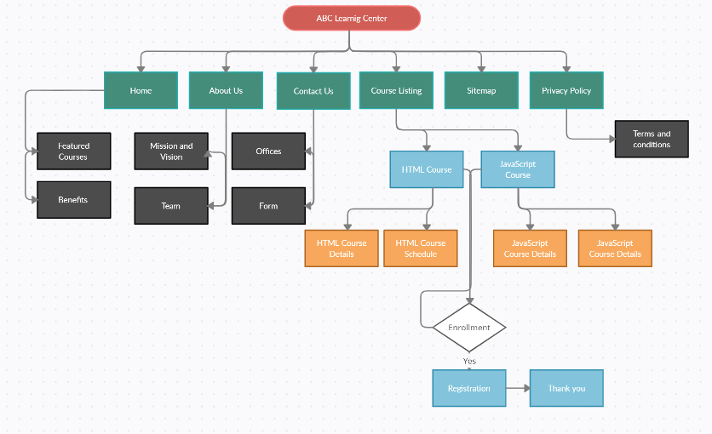

## Wire-frames

Wire-frames are page **schematics** or screen **blueprints** that are visual guide which represents **skeletal framework** of the website. It focus on functions available, relative priorities of information and functions, rules for displaying certain information.

Software available in the market are sketch, adobe illustrator, adobe photo-shop, figma, etc. I am going to use **balsamiq,** which is online tool as well as available as desktop app. I will use the browser version.

This is the home page of the website where we have fixed **navigation bar**, **hero image** and **featured courses** and link to course listing page. It also have what ABC will provide and its **benefits**

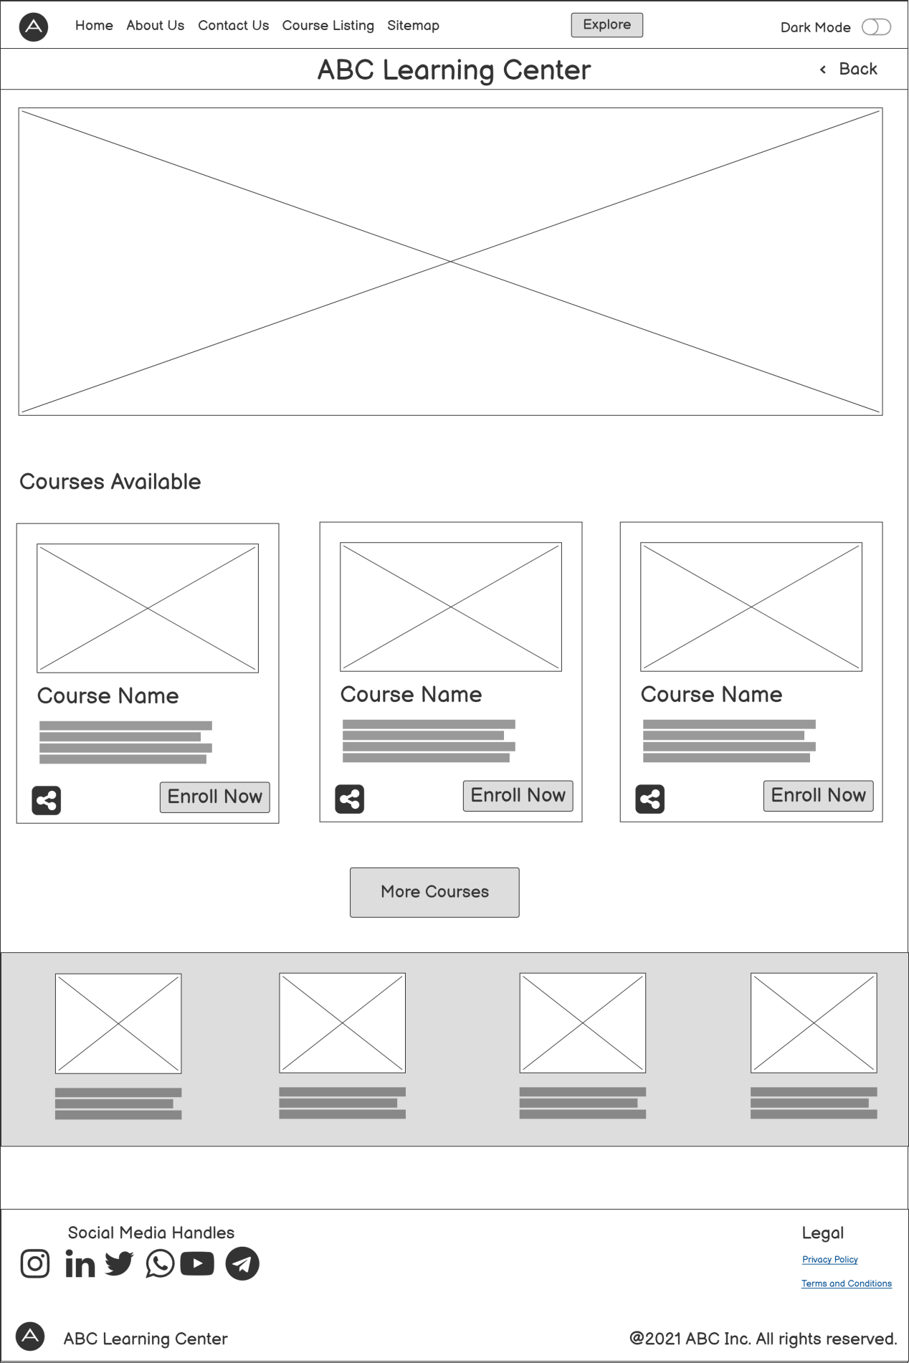

About us page displays what ABC stands for and their **mission and vision**

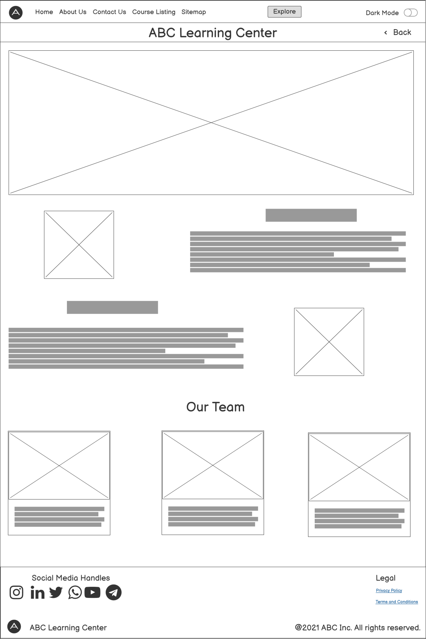

Contact Us page will have info about ABC office and contact information. It also has in-window form where user can directly message.

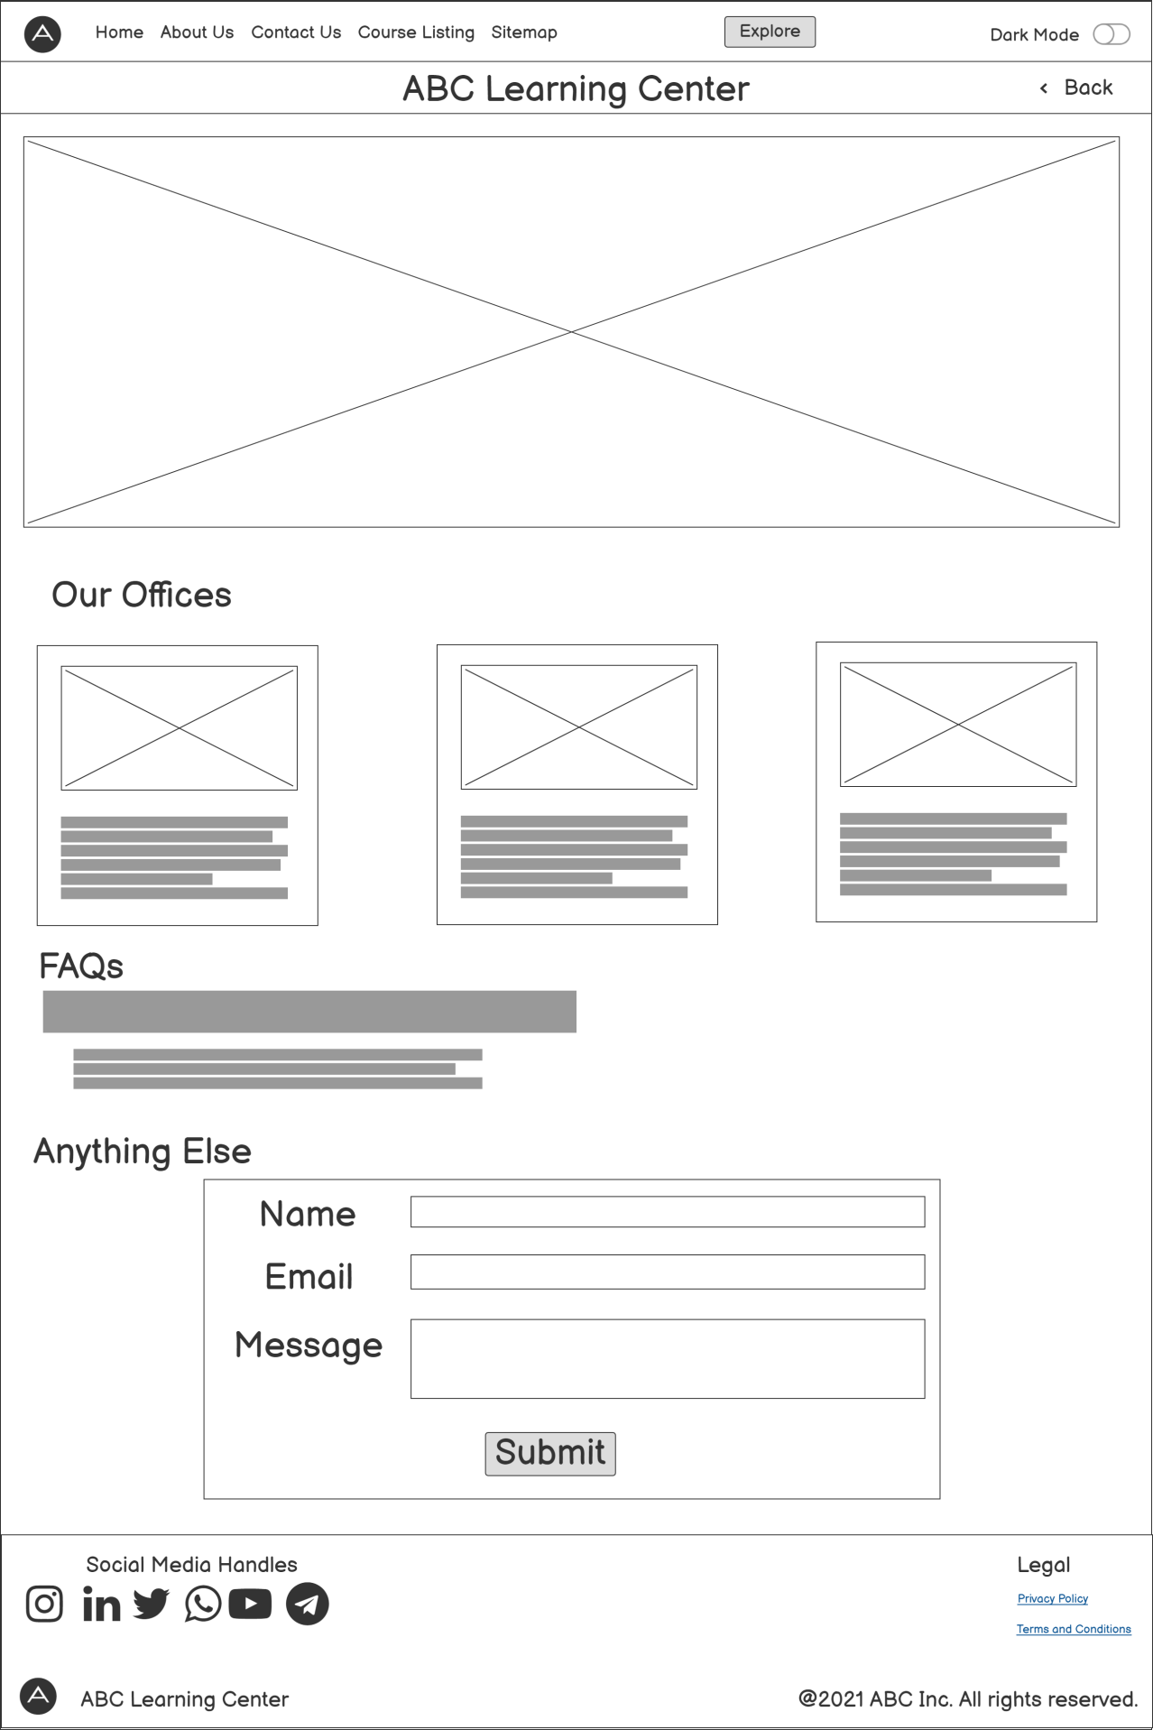

Sitemap will all the links for better SEO

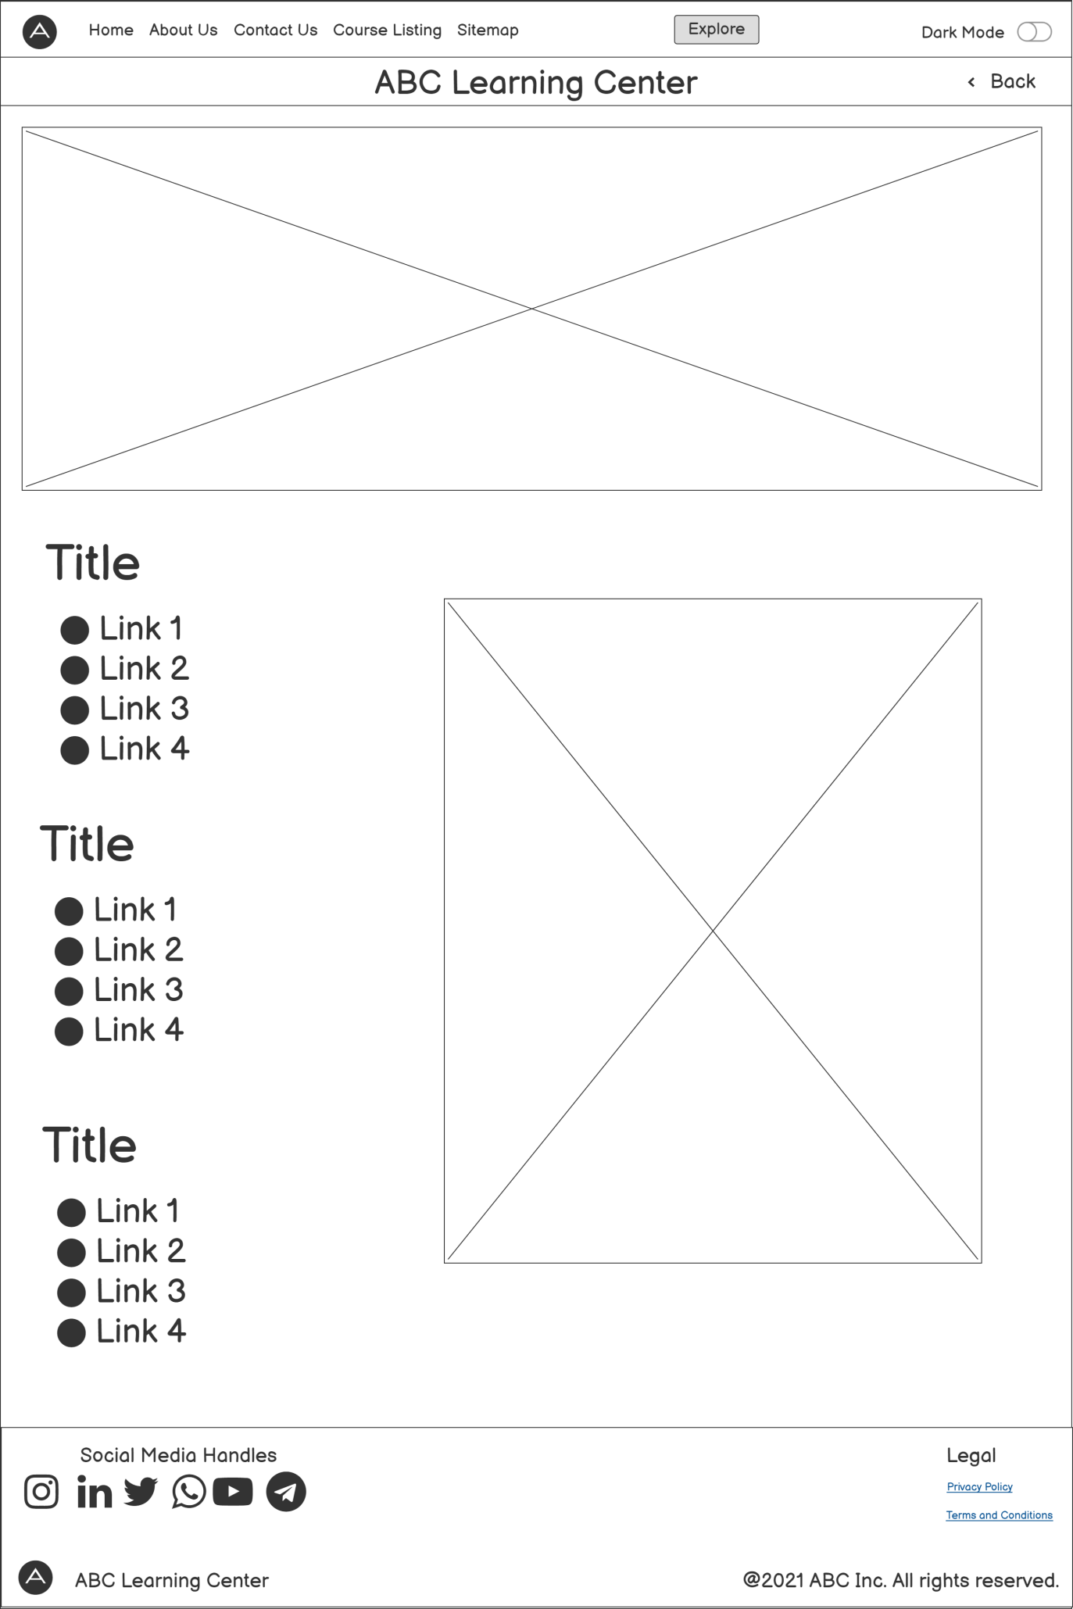

Privacy policy page will contain the term and conditions and guideline for usage.

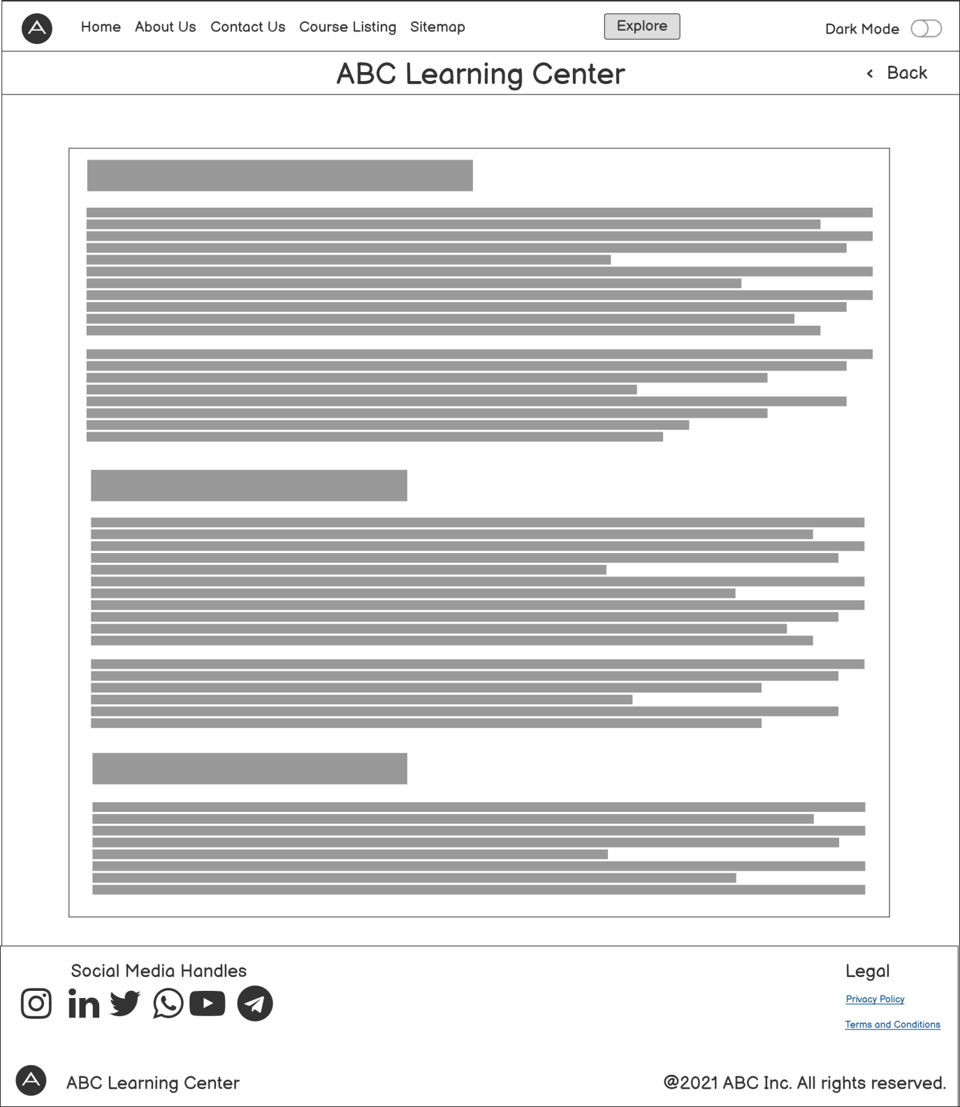

Course listing page

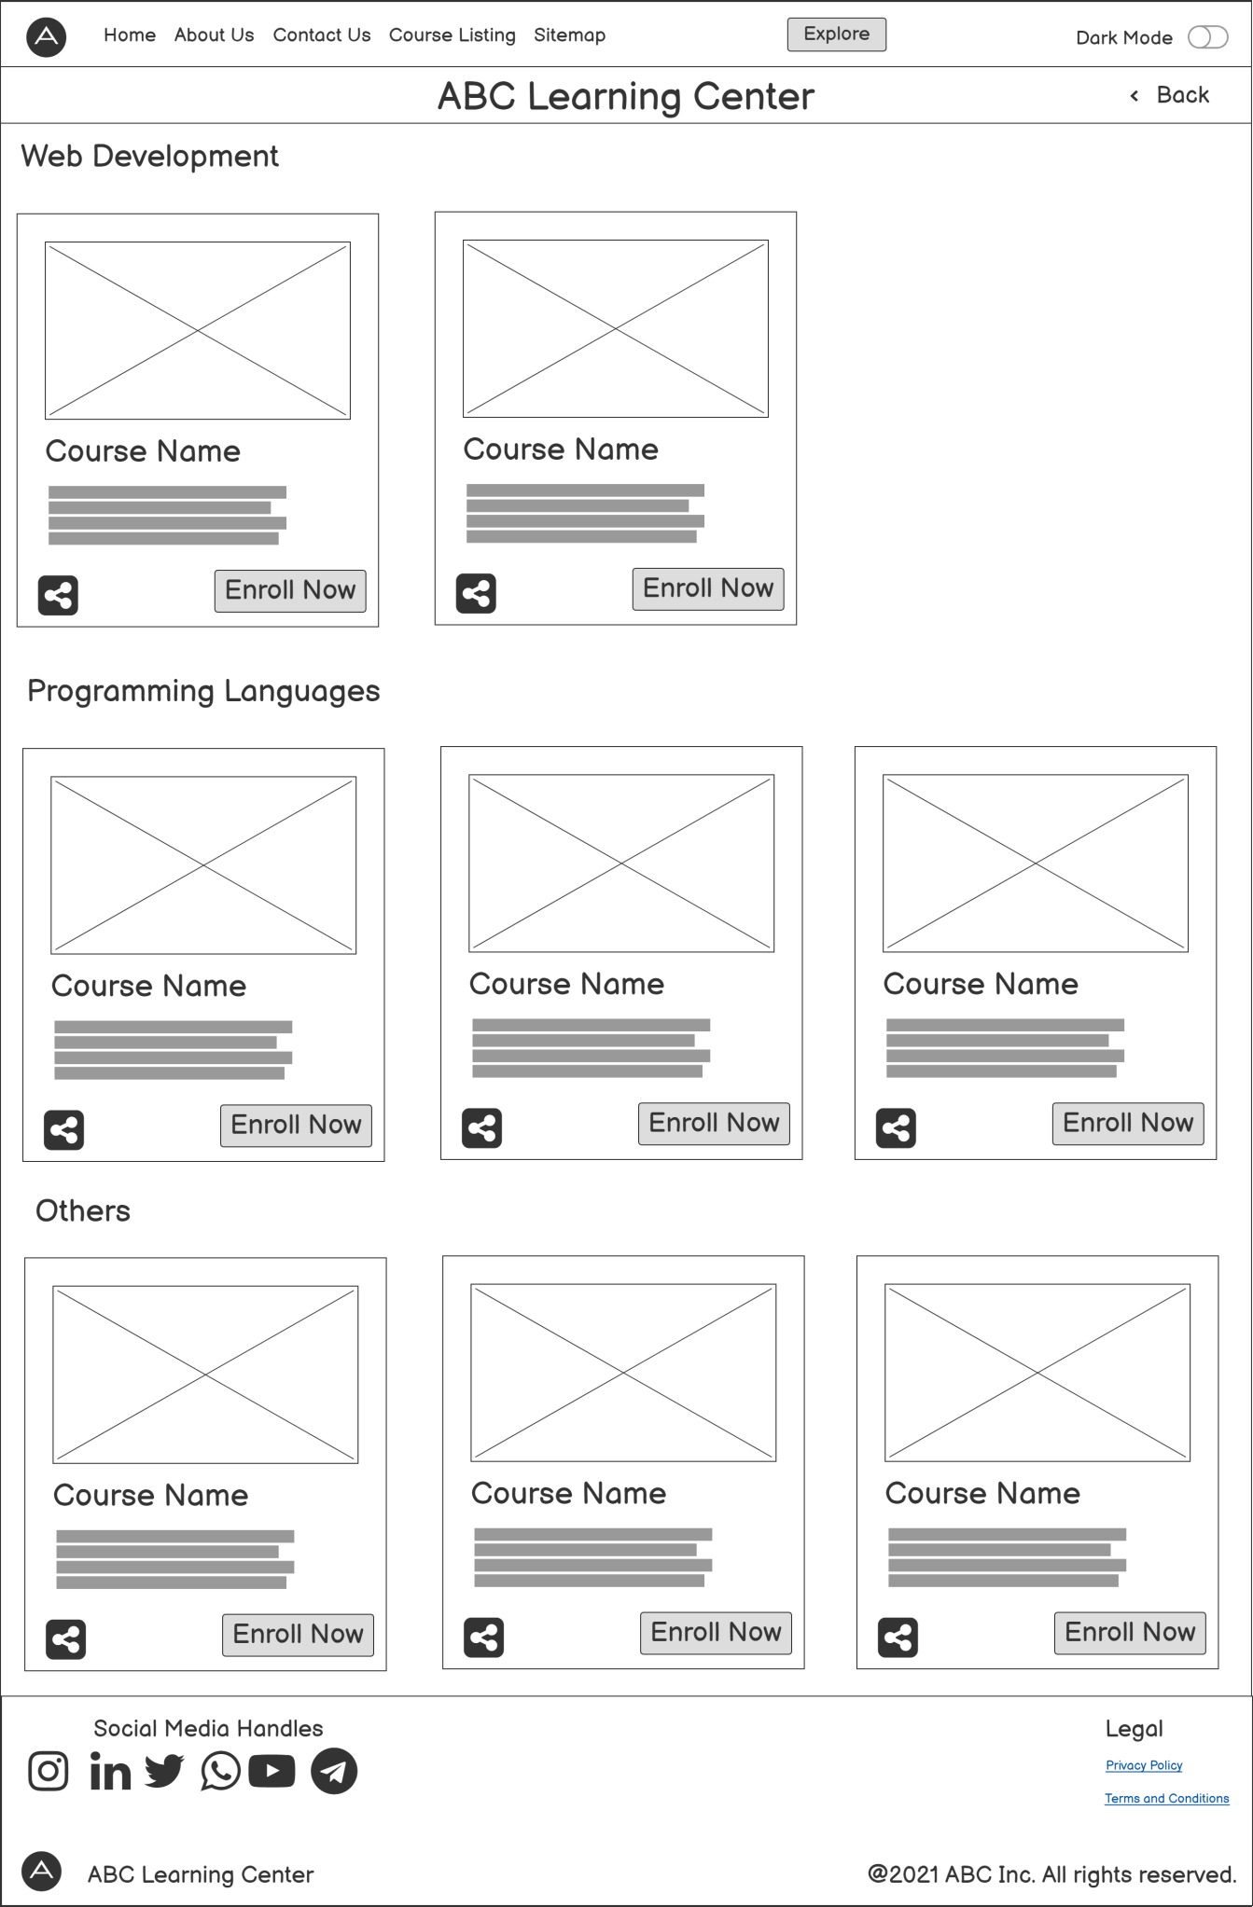

Course Details and schedule page

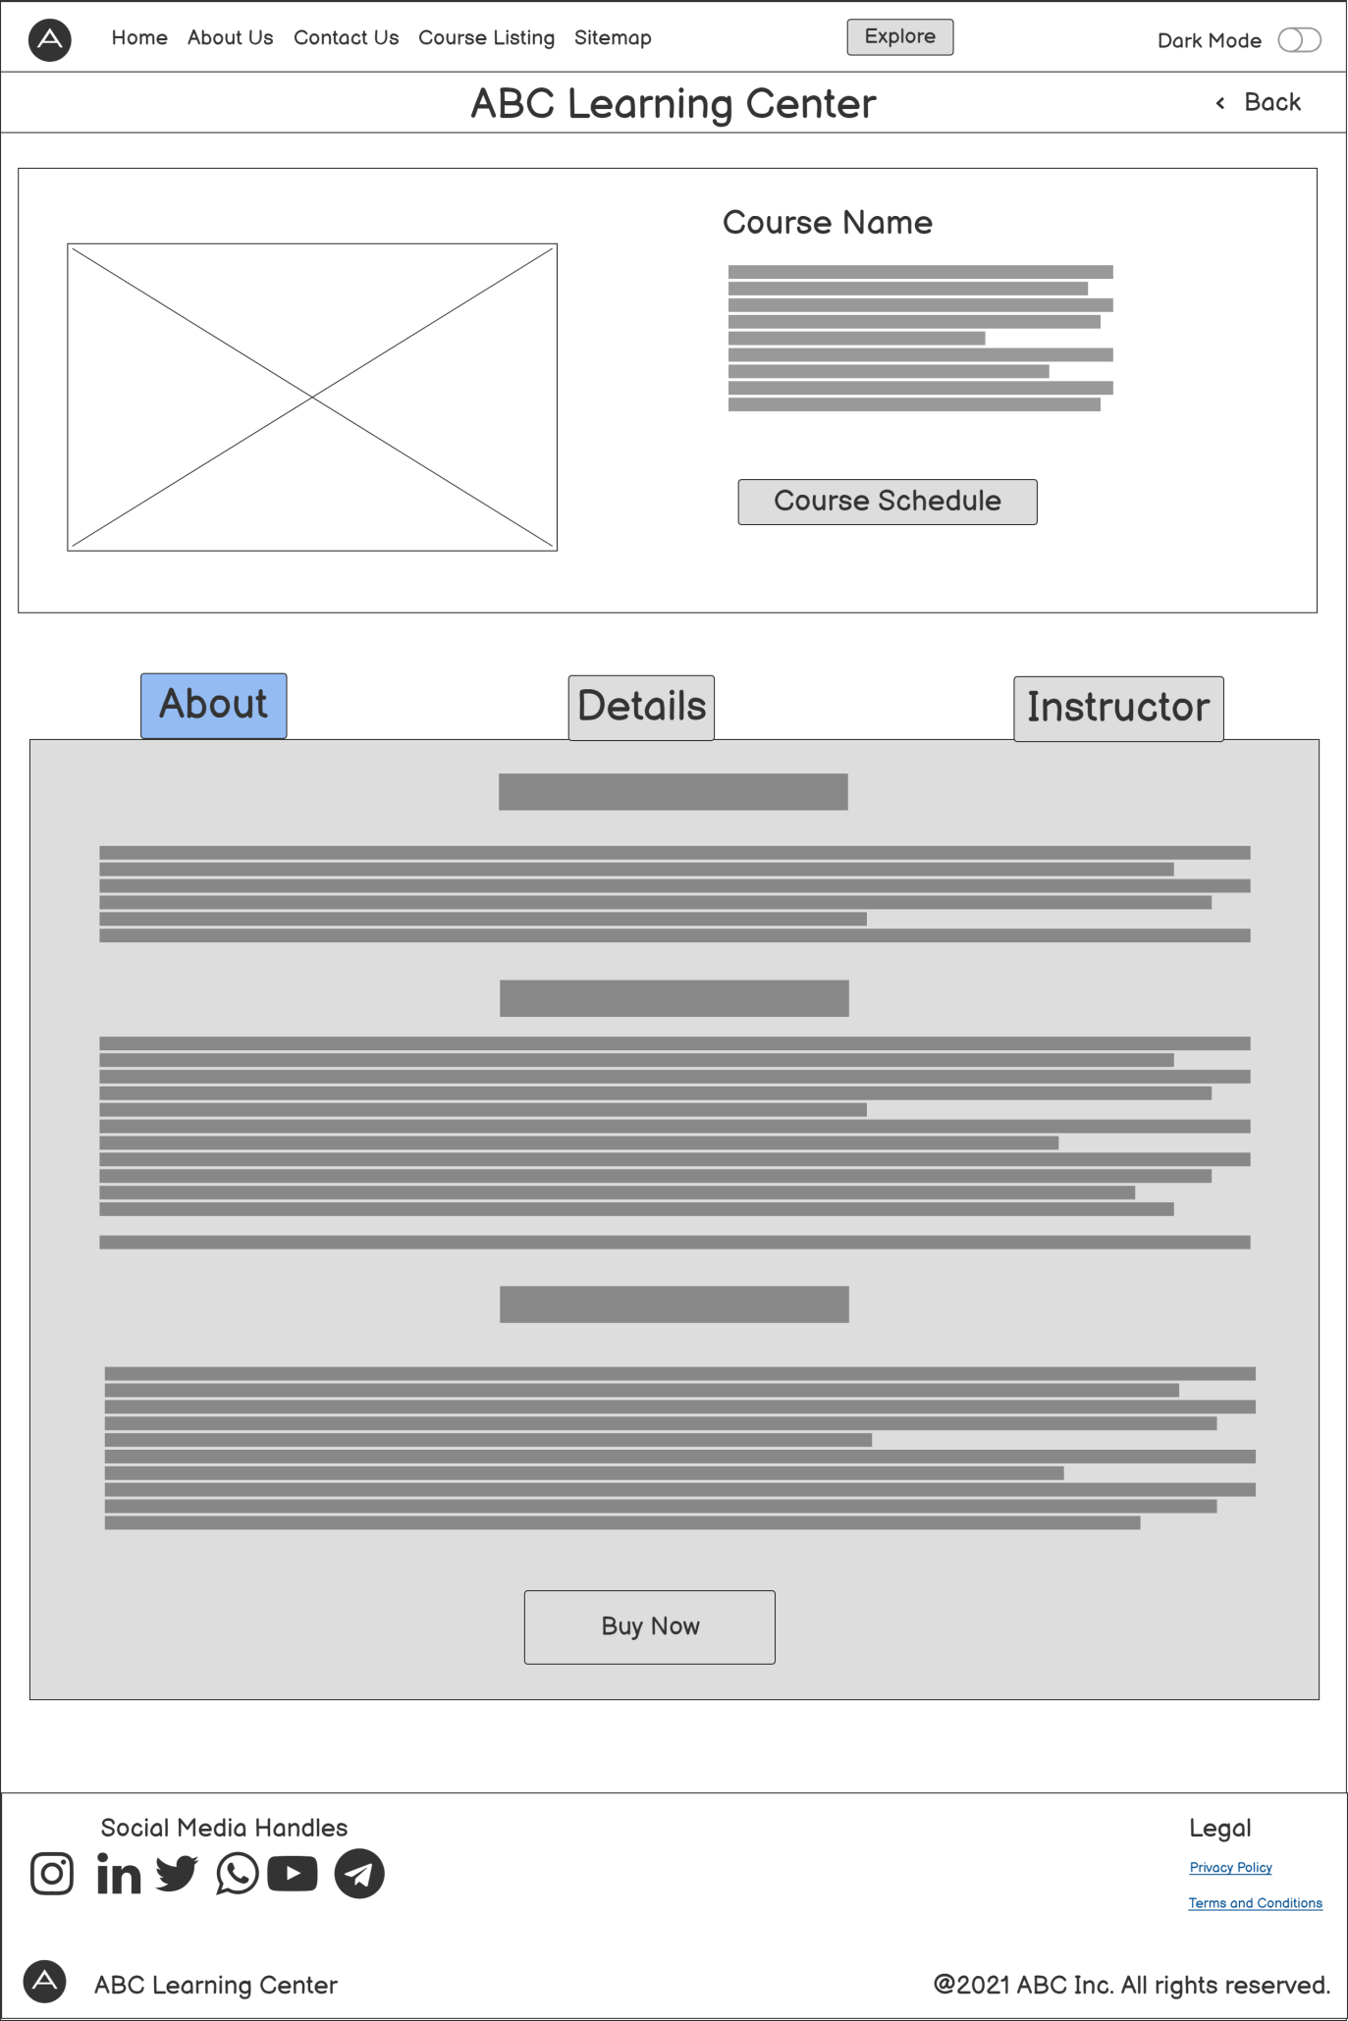

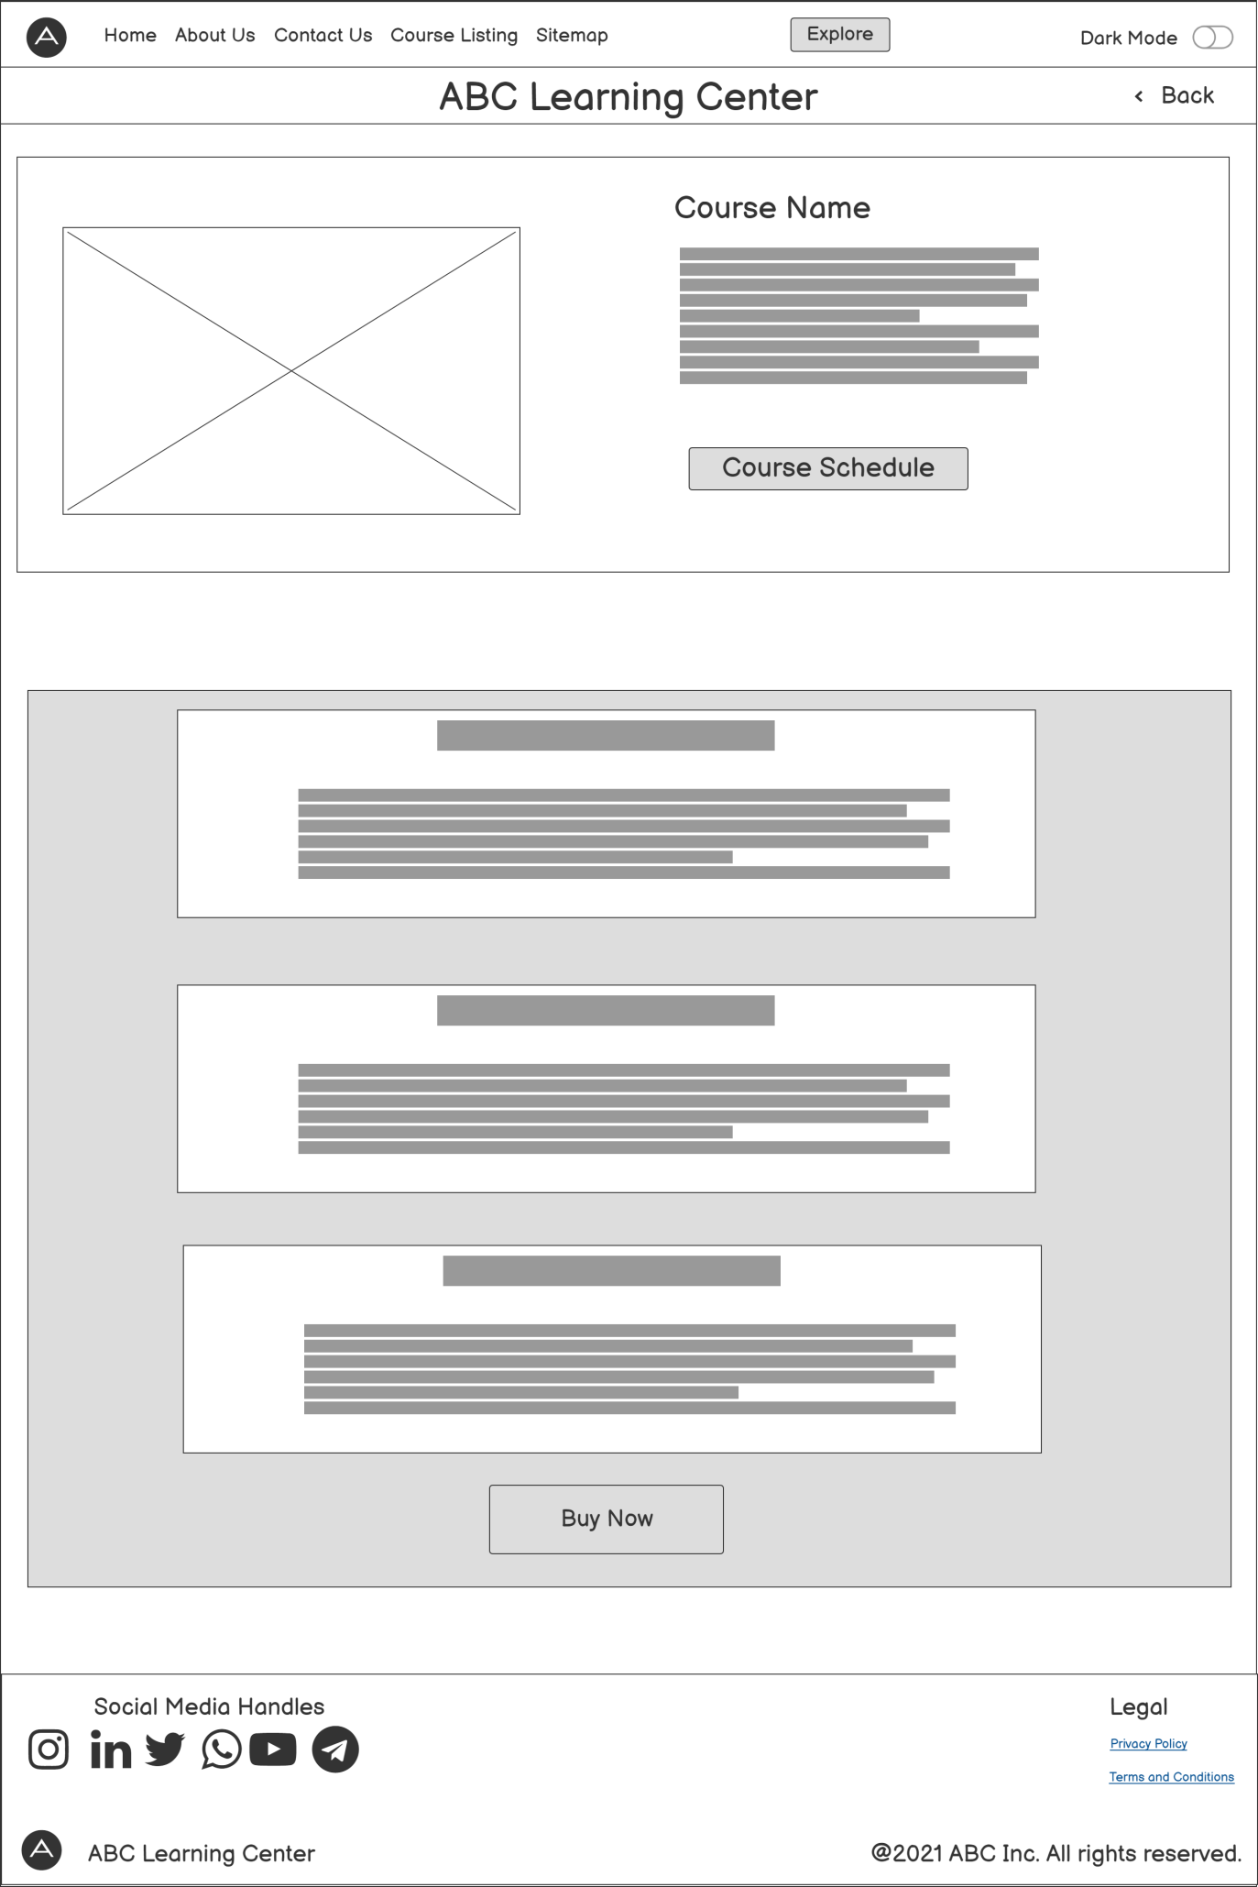

Registration page and thank you page

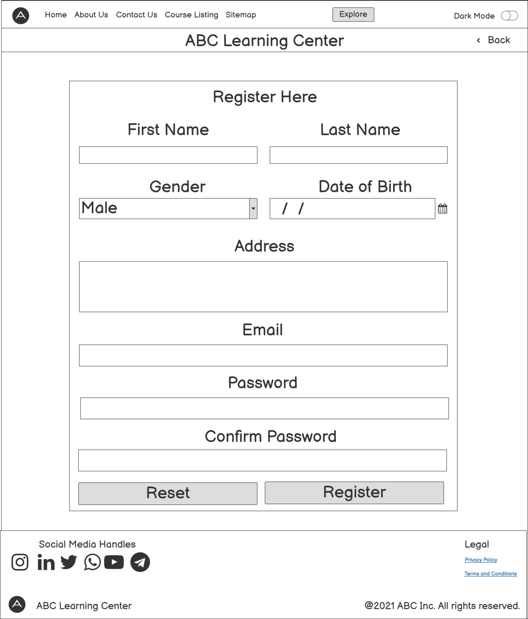

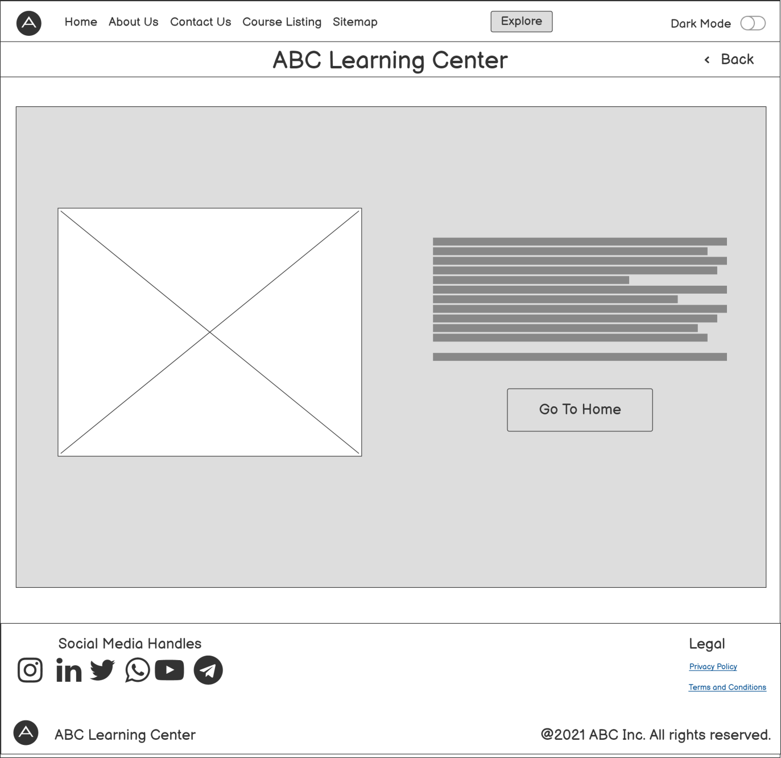

## Storyboard

It is the **blue print** for a website or app. It is a graphic organizer that plans narrative for the website. It is simple and flexible. It serves as outline of design approach. It defines elements that needs to go on each page. It shows **navigational architecture** and information flow and demonstrate how pages work together. Adobe After Effects is most commonly used software.

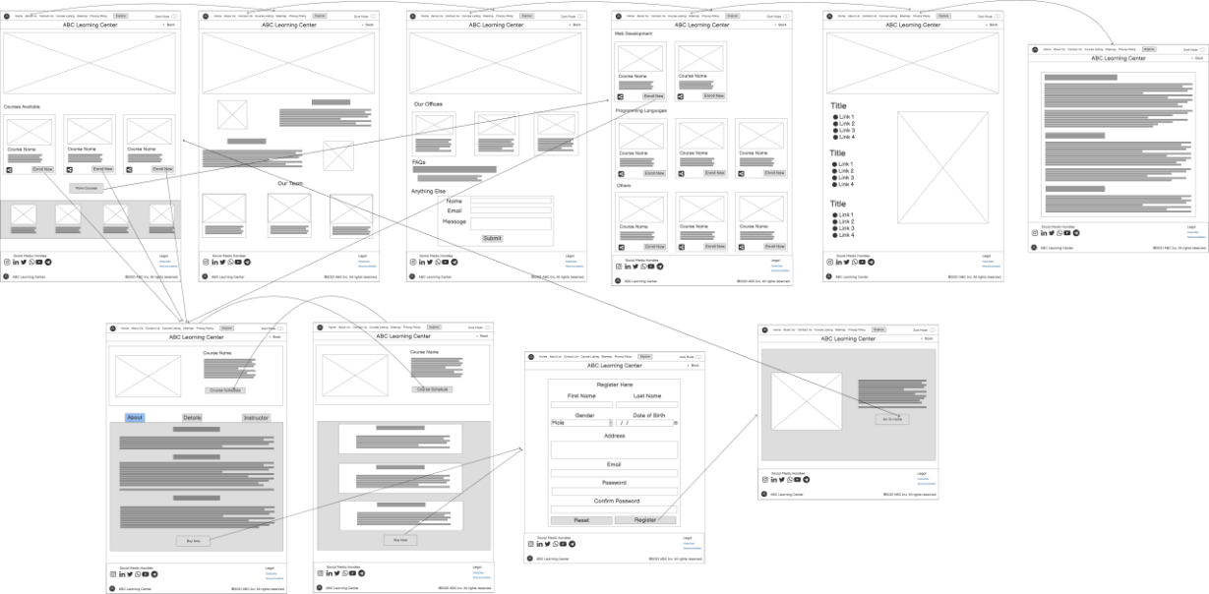

# Website Design Guidelines and Standards

## Intro

Planning for website design and development will save time and gives you direction to move forward. Planning for a website includes setting a goal, set the number of pages and its content, technology that suites you. Design documents like wire-frames and storyboards for visual representation. Setting the guidelines and design patterns for the project which make it maintainable and readable.

## Plan

In my case, I have been assigned to develop website by ABC Learning Center. So first thing I will do is to **understand** what are the **requirements** and **expectations** of the ABC Learning Center. What they they think are the user’s expectation. What is their **target audience**.

After understanding the requirements I shall do my own **research** about the **user** and **resources requirements** and **market** research. This will help me to understand their position in the market and their **competitors**.

Now I need to finalize the **number of pages** and their **content**. Select the **technology stack** that I will be working for developing the website. Since this is a website **HTML** and **CSS** are must and to make interactive I will use **JavaScript** and **Jquery**. Other resources which will be need are **font awesome** for icons, **AJAX** for communication, **Apache HTTP server** for hosting, etc.

Since I have the pages its content, I will need some visual representation of it to show it to ABC. I will develop **Information Architecture**, **wire-frames** and **storyboard** and will finalize the design with clients.

After the design phase is complete, development will start in the order of priority to the pages. Coding **guidelines** and **best practices** along with **responsive design** will be followed. Website will also be **SEO friendly**. The development will be followed along with **tests** to ensure that nothing is broken.

Once all the tests are passed and website is ready, it will be **deployed** to the server and will be **released** to public for consumption.

To sum it up, this are the steps that needs to be followed

1. Understand goals and expectations of ABC Learning Center
2. User requirements and market research
3. Decision of pages and tech stack
4. Design Documents
5. Development
6. Testing
7. Deployment

## Hosted Website

Here are the screenshot of the website that I created and hosted on my computer. All the images are full screen views of the web-page

This is the full screen screenshot to show the URL.

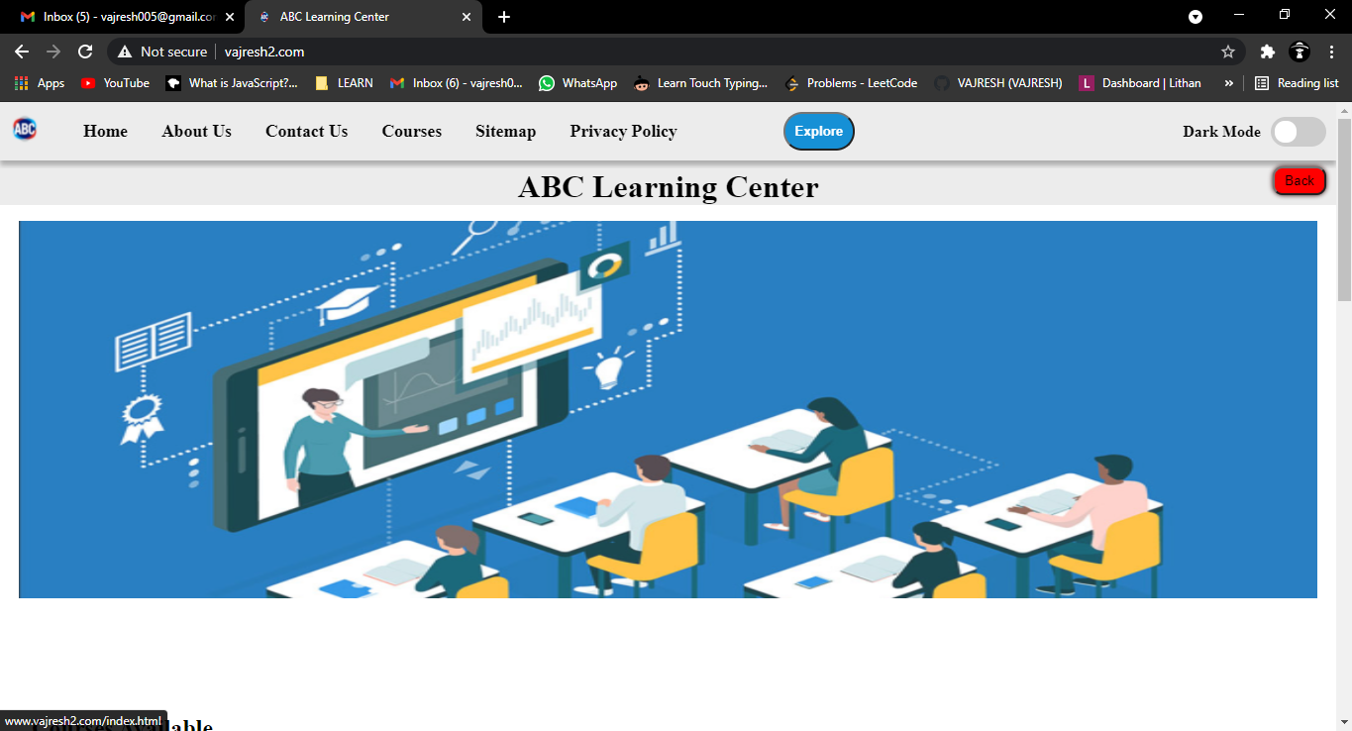

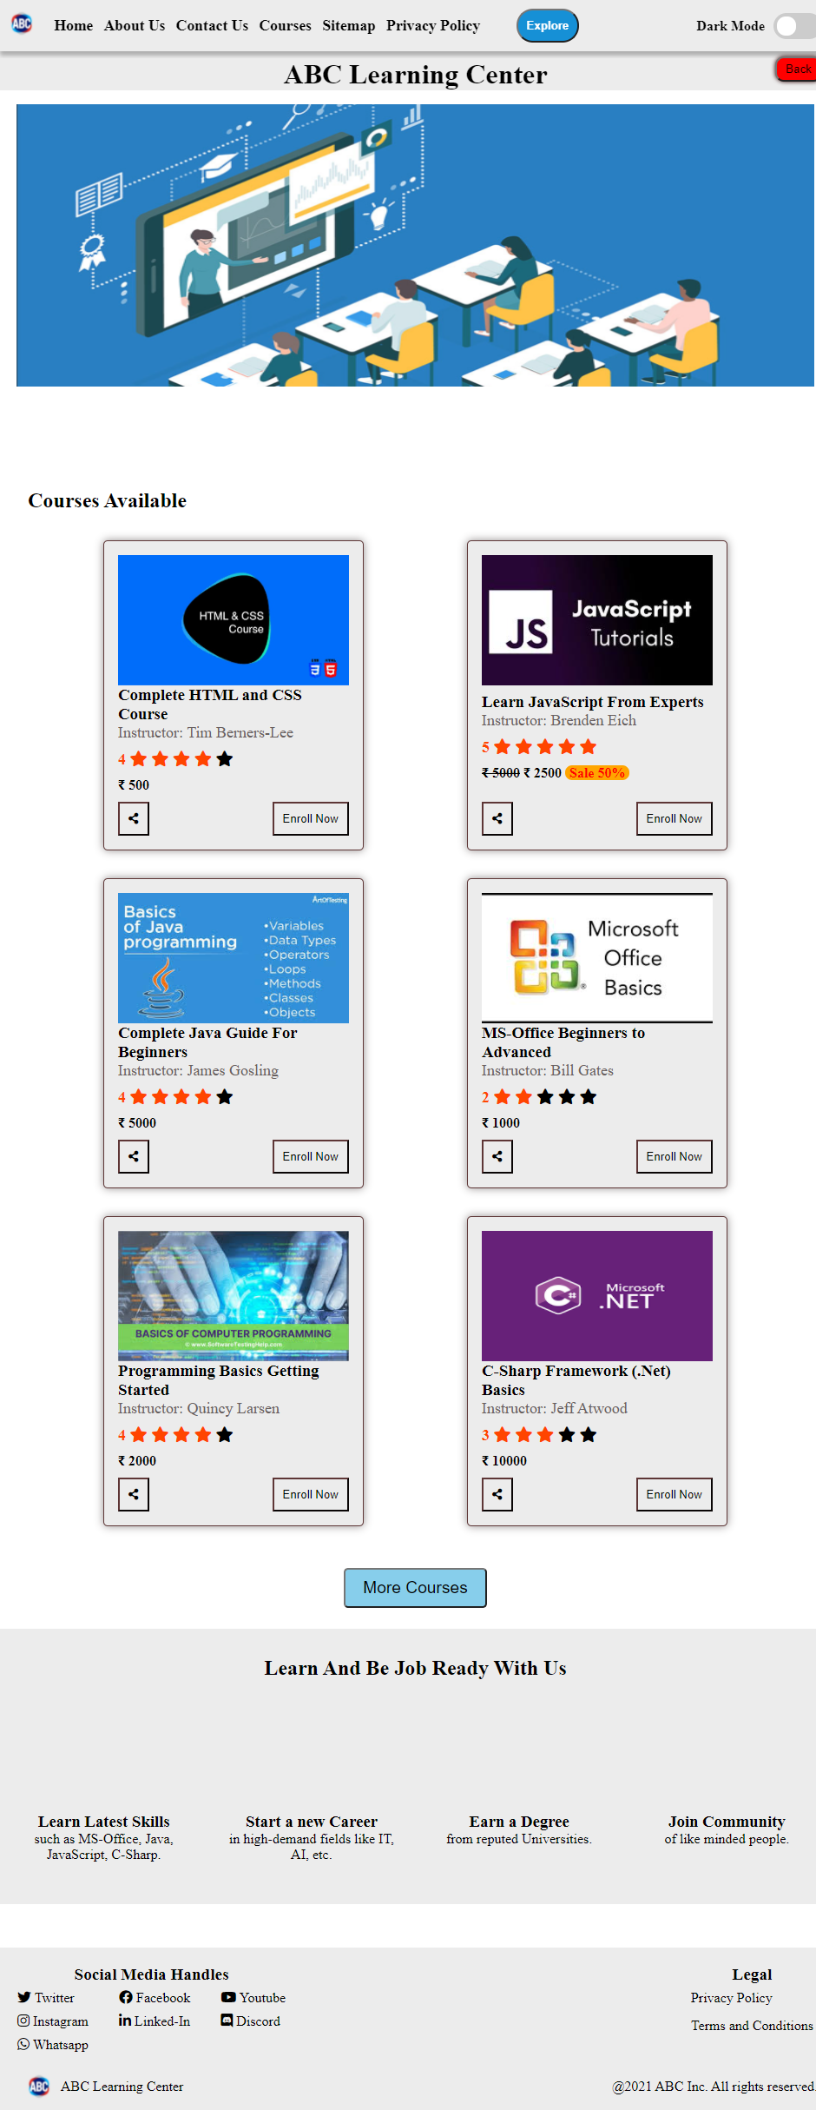

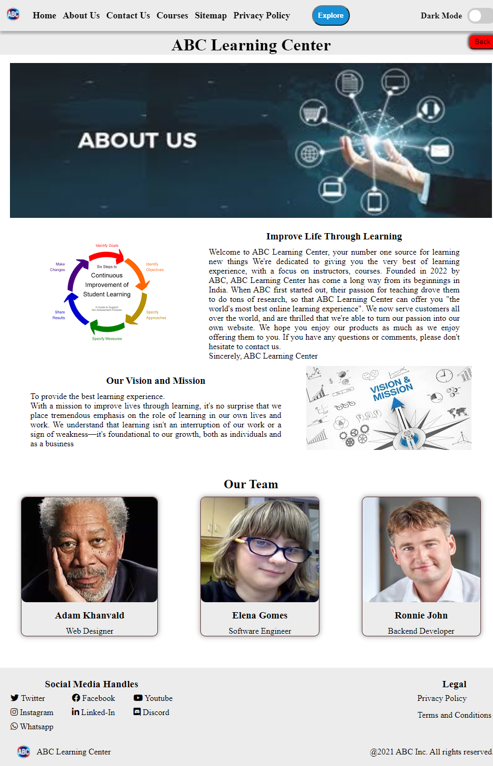

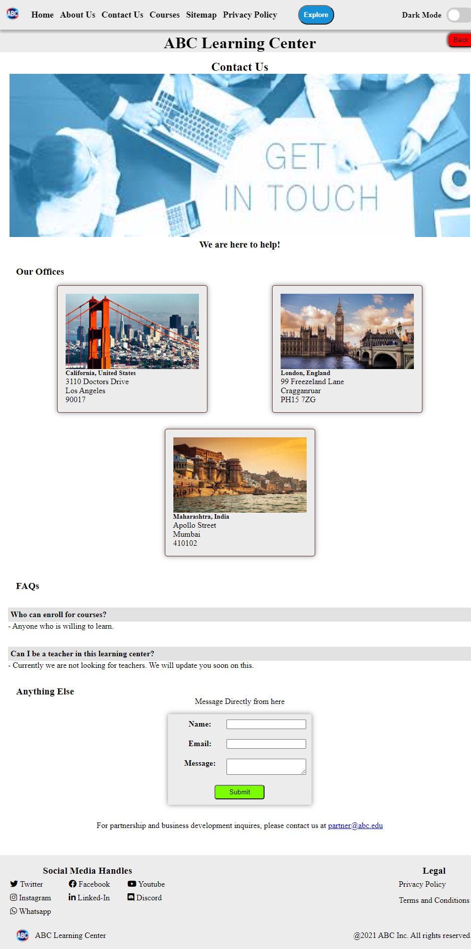

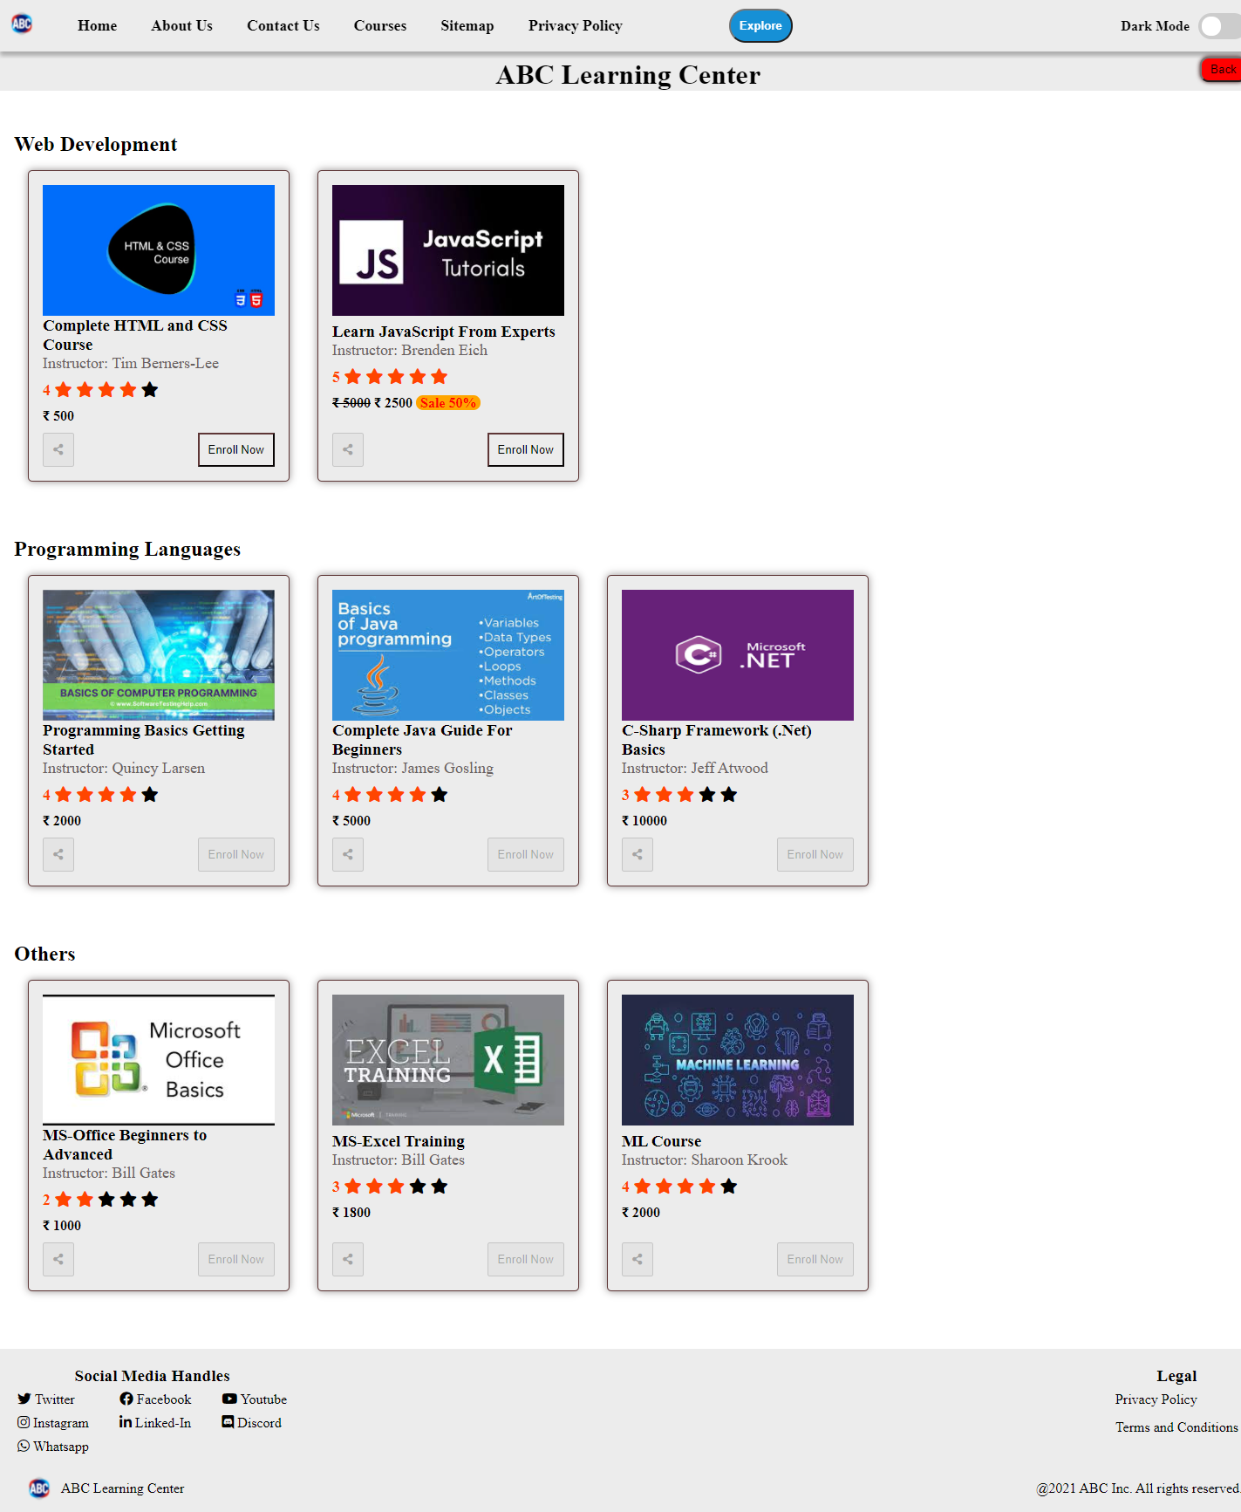

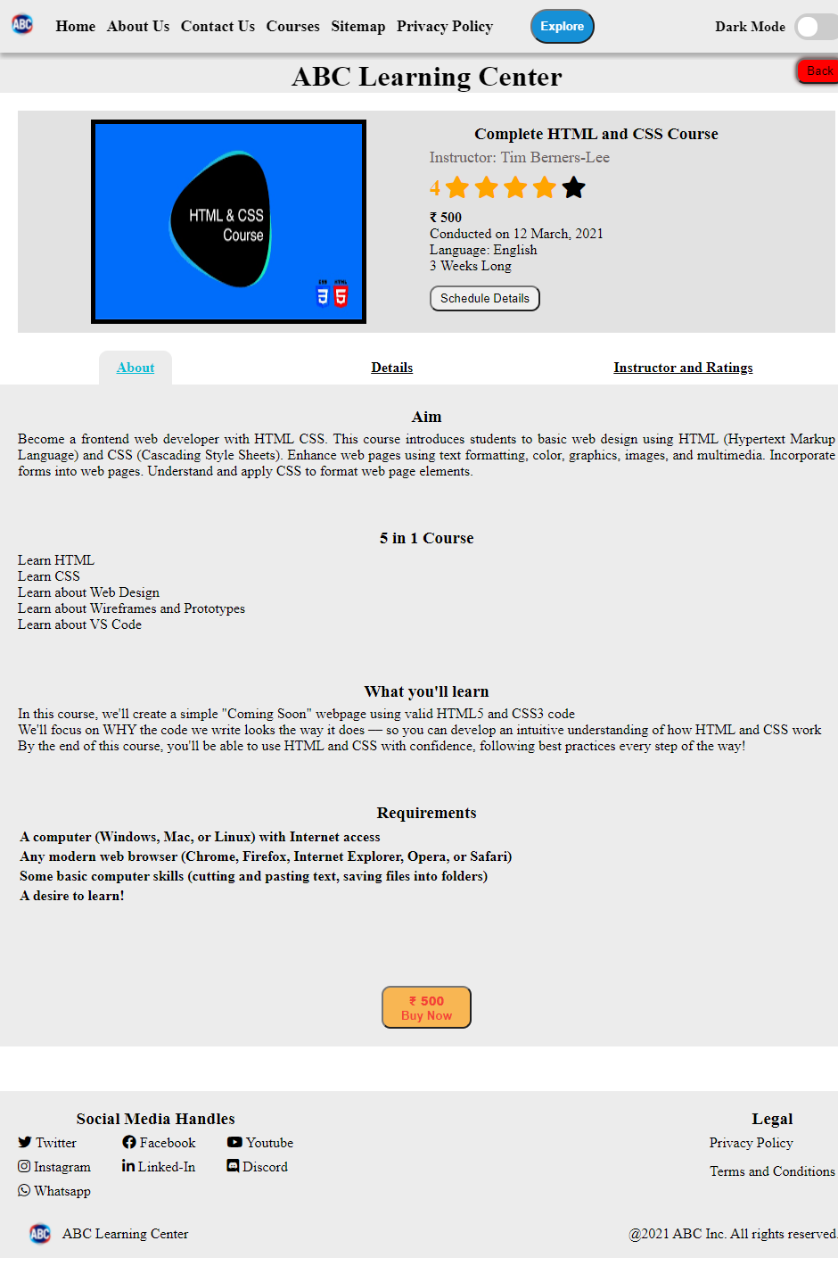

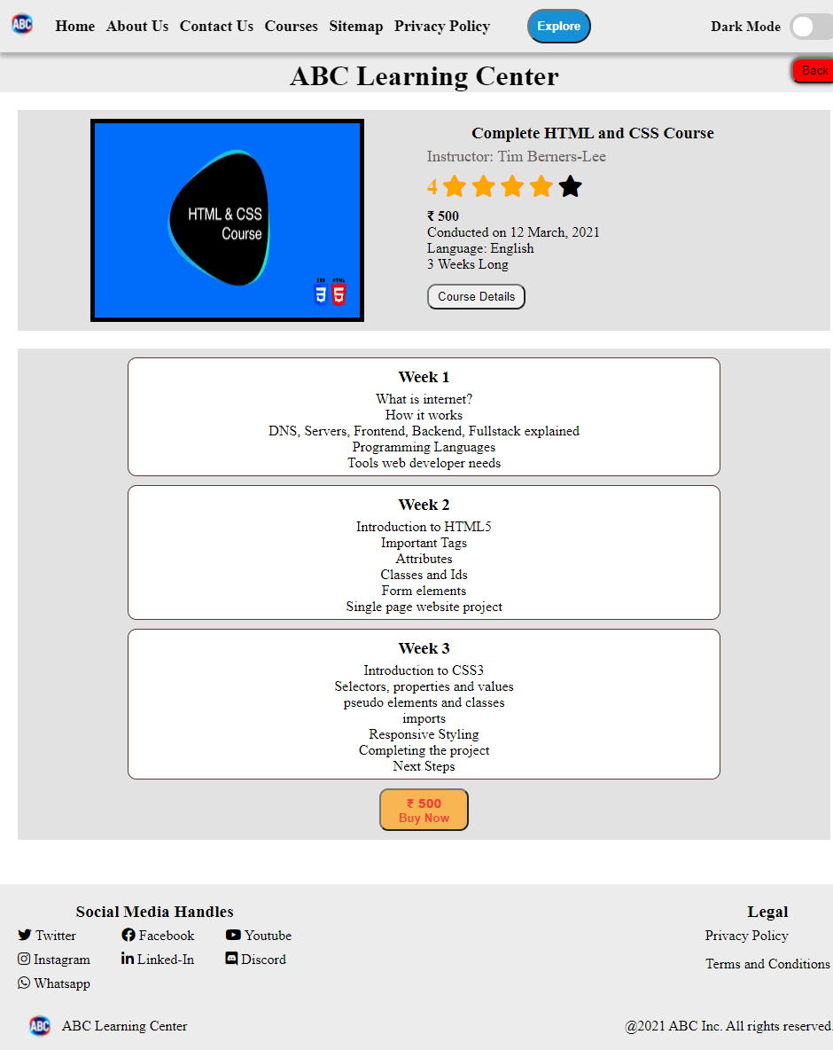

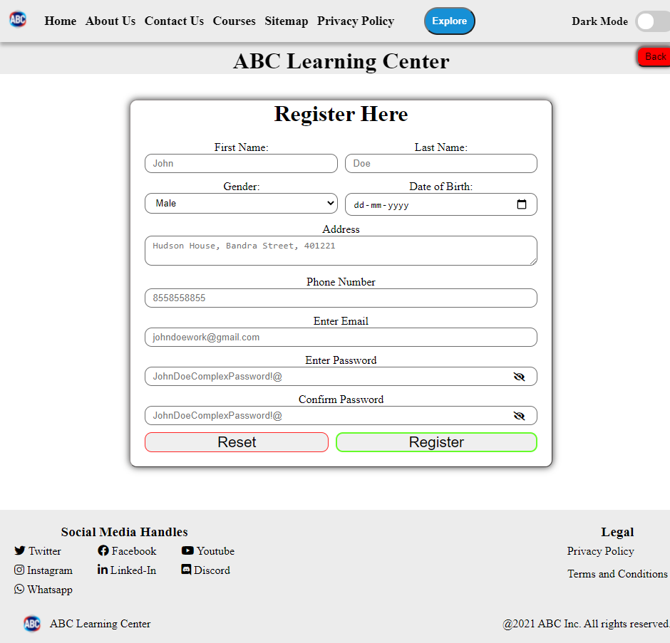

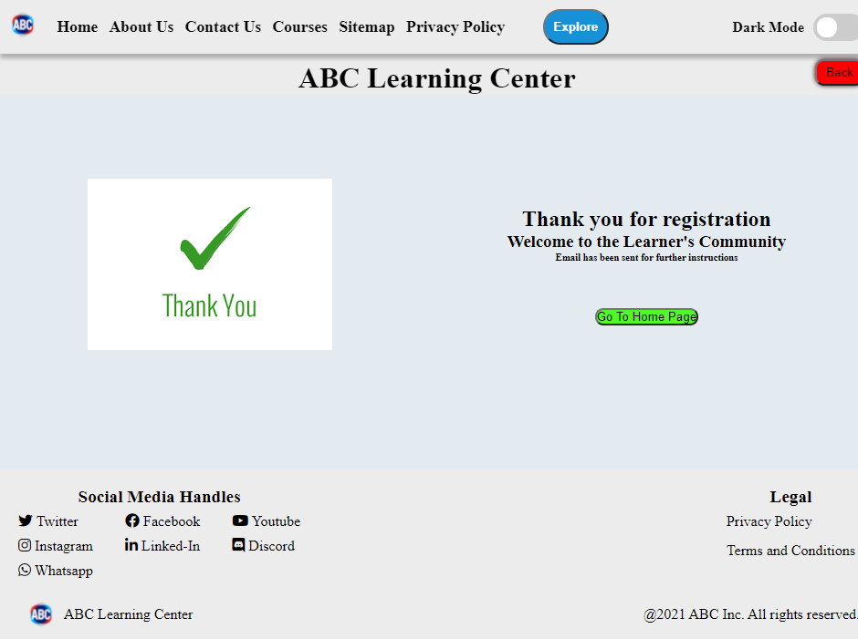

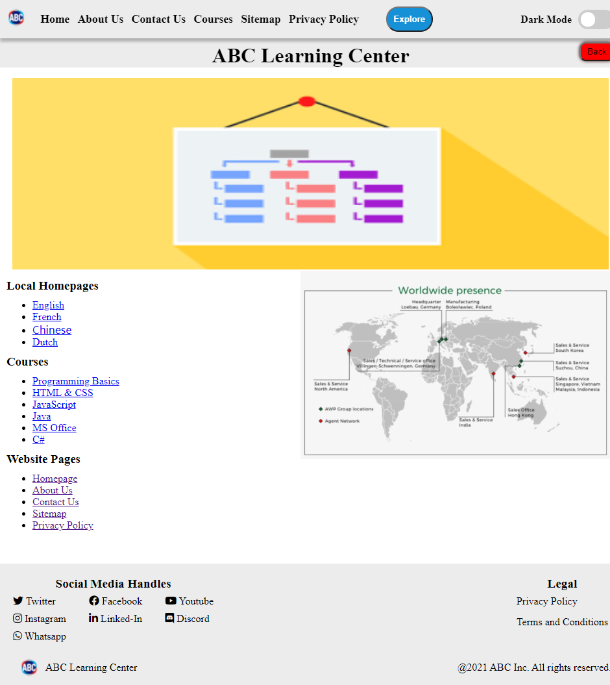

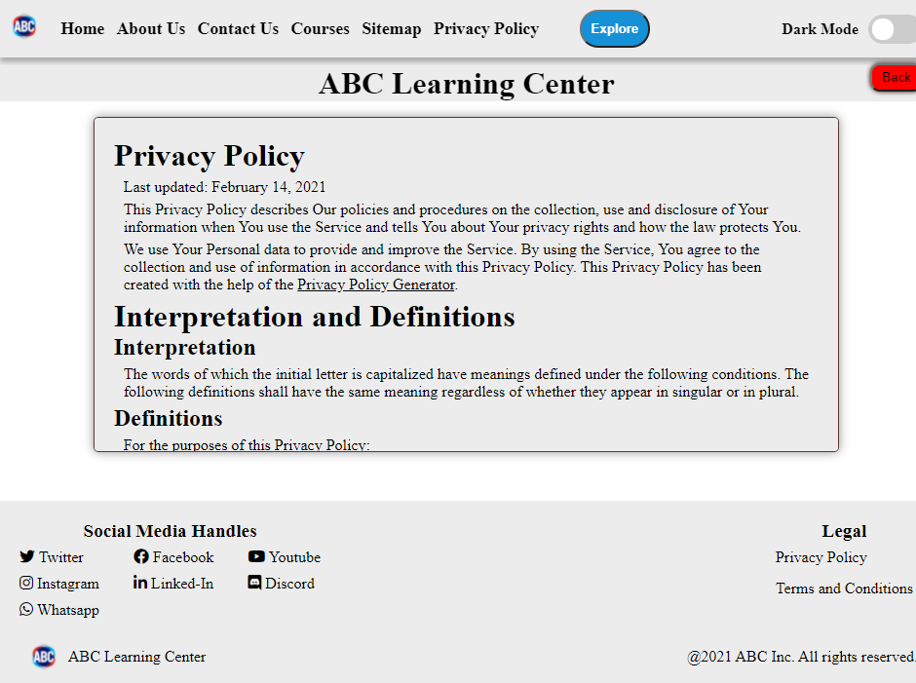

This is dark mode of the website, just home page is shown here

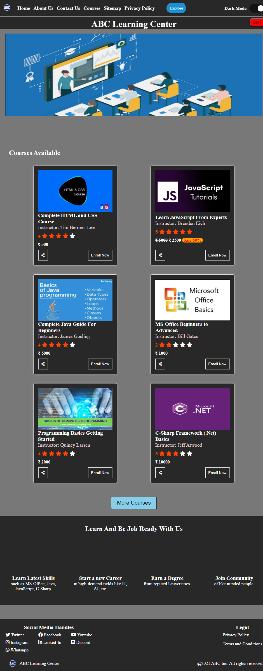

# Website Testing

## Intro

Testing any software product ensures that it has less bugs and it saves time in the long run. Website needs to be tested in many fronts such as testing about security, performance, SEO friendliness, best practices, integration, interactivity and functionality, cross browser compatibility, etc. There are many tools and techniques that helps you to test your website and identify any potential bugs.

## Testing Approach

There are many ways you can integrate test cases in your application. There is an entire approach called Test Driven Development. There are many libraries that can help you in testing your application.

Jest is one such library that helps to test websites and is written in JavaScript. It is fast and safe, requires zero configurations, isolated and available for many different JavaScript front end libraries like react, jquery, angular, vue and as well for babel and others.

Another way is using tools for testing. There are markup validation tools which check for HTML pages. They test your HTML page to have semantic structure, follow best practices. One of the example is w3c markup validator. It takes HTML file and display any errors and warnings.

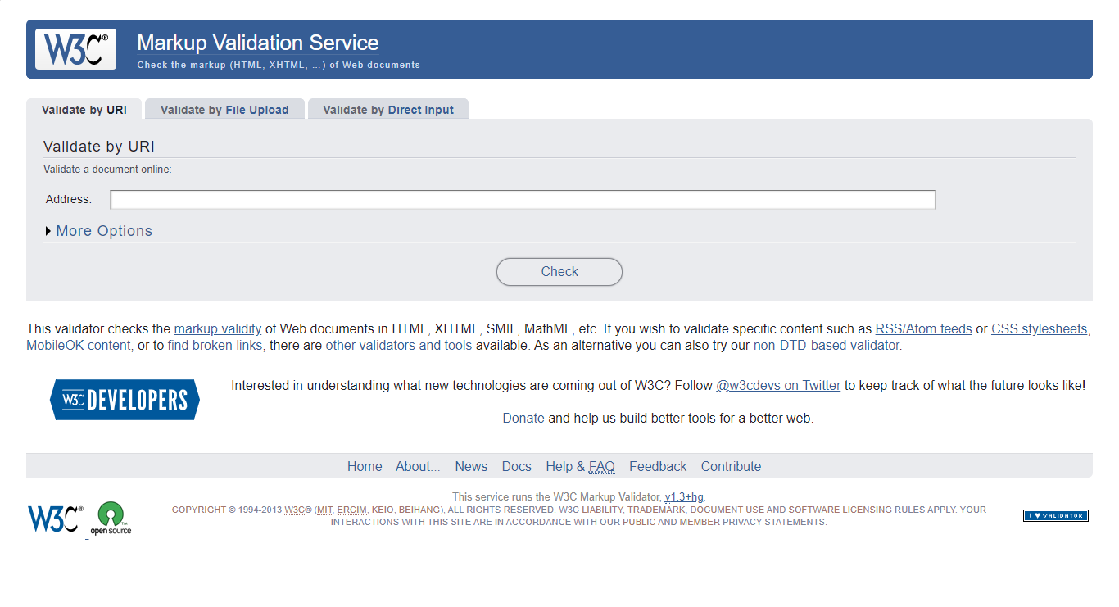

Google also has one such tool called Lighthouse which tests your websites performance, best practices, SEO, accessibility and gives your site a score and provides suggestions for improvements.

## Test cases

**Screenshot** 1: HTML Validation

This is tested on w3c markup validator.

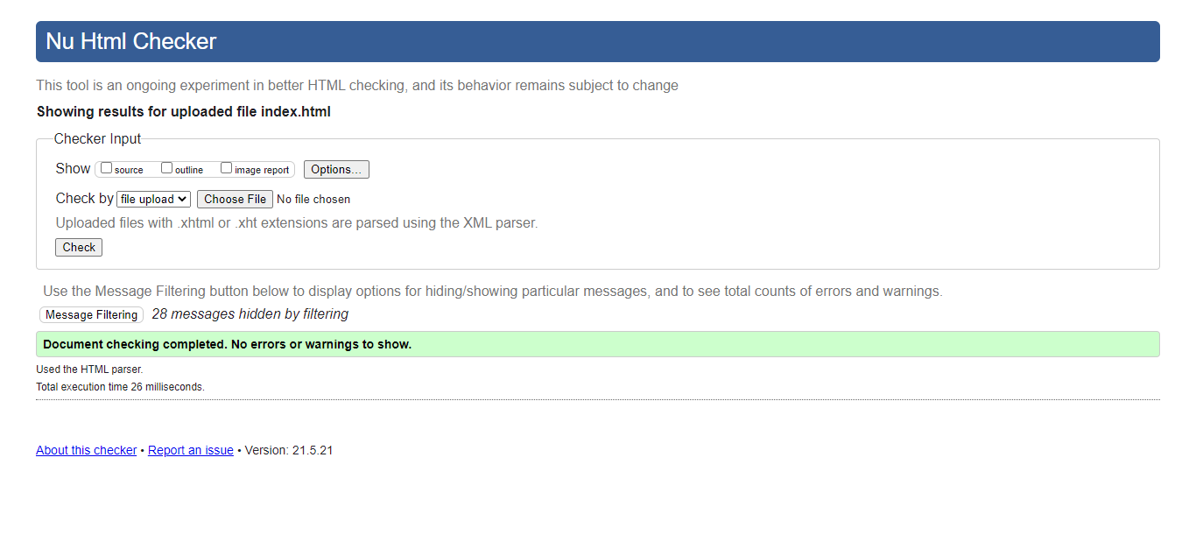

**Screenshot** 2: CSS Validation

This is tested on w3c CSS validator.

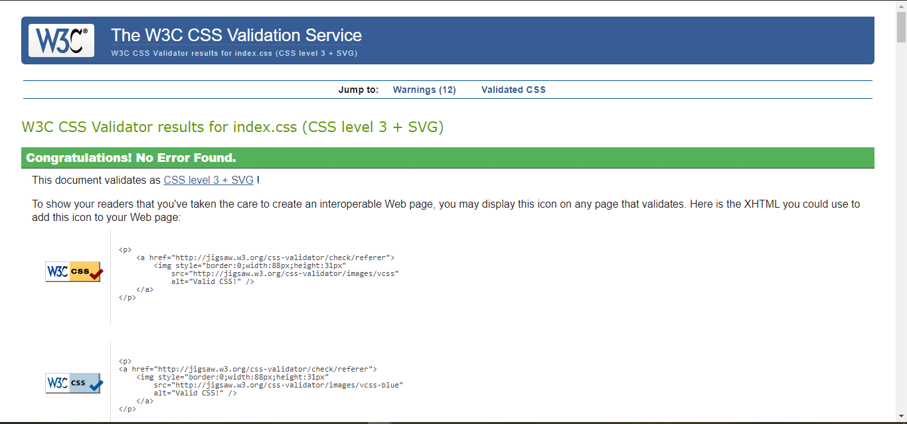

**Screenshot** 3: Best Practices

This is tested on Google Lighthouse. Since I am hosting the website without SSL certificate, it affects my scores.

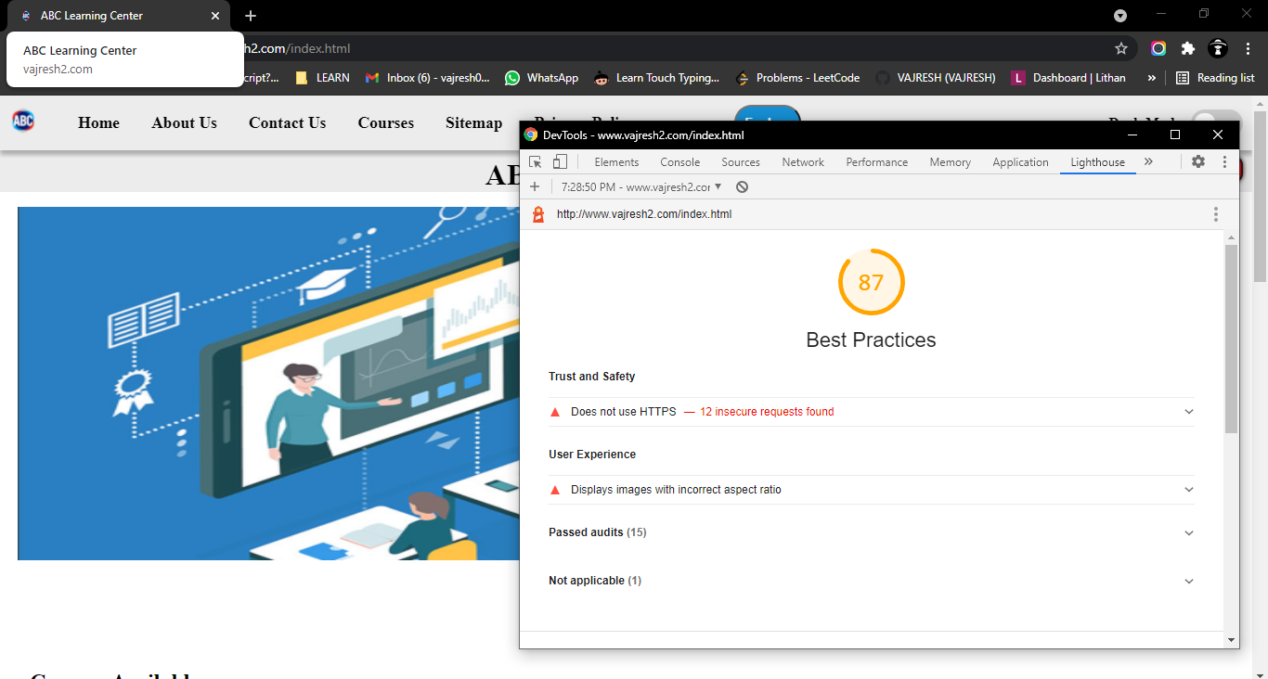

**Screenshot 4**: SEO

Tested on Google Lighthouse.

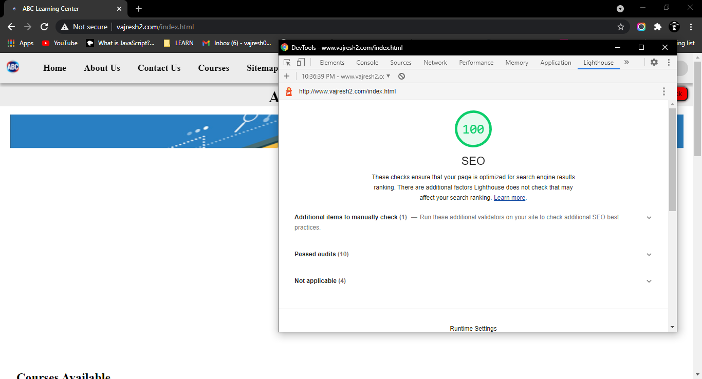

**Screenshot 5:** Responsive Header Design

This is emulated with the help of browser dev tools to stimulate the mobile screen size.

Desktop Screen:



Mobile Screen:

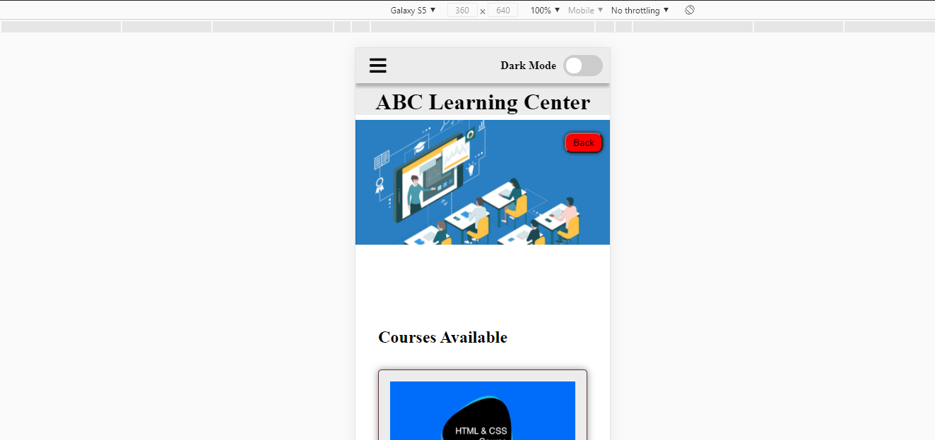

**Screenshot 6:** Disabled broken links

The enroll now button of the course which are not available are disabled.



**Screenshot 7:** Form Validation

Error message displayed when invalid email is entered

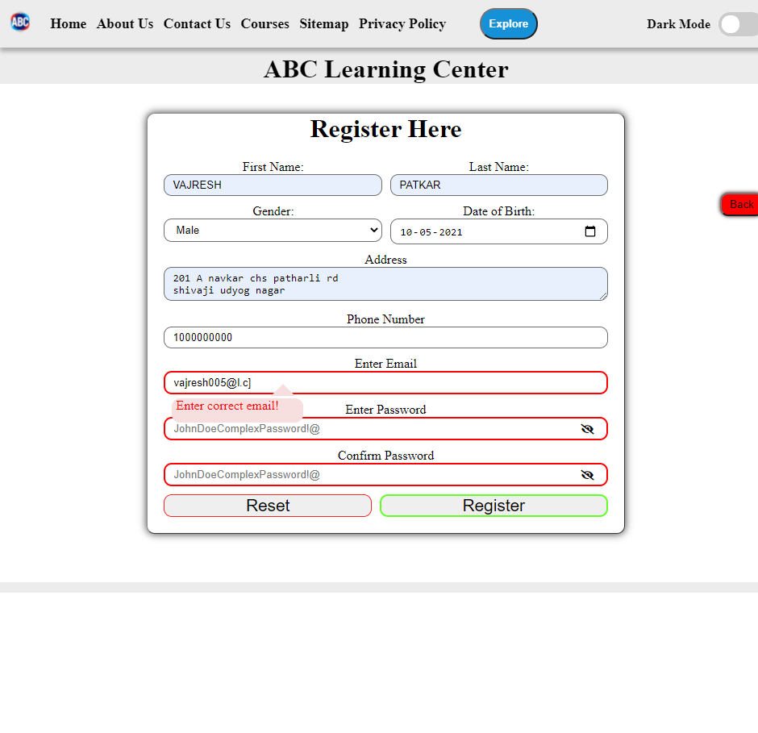

**Screenshot 8:** Drop down menu

The menu is visible when user clicks on the explore button.

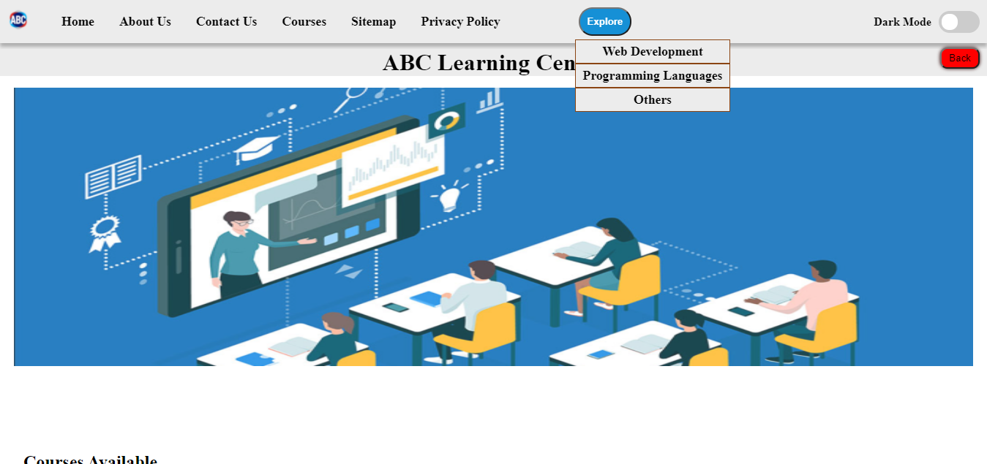

**Screenshot 9:** Tabs

Out of 3 tab section only one is visible at a time



**Screenshot 10:** Dark Mode

Website should be change the colors based on the selection of dark mode selector.



## Tabular Format

|  |  |  |  |  |  |
| --- | --- | --- | --- | --- | --- |
| **Test Id** | **Test Case** | **Expectation** | **Actual Result** | **Pass/Fail** | **Evidence** |
| 1 | Validate the HTML files to follow all the best practices, semantic structure | No Critical Errors | No Critical Errors received | Pass | Refer to screenshot 1 |
| 2 | To identify CSS errors, typos, incorrect structures as CSS don’t give errors and warnings. | No Critical Errors | No Critical Errors Received | Pass | Refer to screenshot 2 |
| 3 | Best practices test to be followed in the website | Above 80 (as I don’t have SSL certificate) | Score is 87 | Pass | Refer to screenshot 3 |
| 4 | SEO friendliness to ensure that it is ranked high in search result | Score should be above 90 | Score is 100 | Pass | Refer to screenshot 4 |
| 5 | Responsive header design for mobile and tablet screen. | Should not break the flow of the page and overlapping | Adapts to screen size | Pass | Refer to screenshot 5 |
| 6 | No Broken Links in the website | All links should redirect and others must be disabled | Broken links are disabled. All links are working as expected. | Pass | Refer to screenshot 6 |
| 7 | External CSS files and JavaScript Files are linked | Designs and interactivity must be applied | Website is interactive and designs are applied | Pass | Refer any screenshot of the website 1-6 |
| 8 | Form data validation to ensure correct data is received | Error message to displayed on invalid entry | Error message is displayed | Pass | Refer screenshot 7 |
| 9 | Drop down works on click to provide links | Drop down is displayed on click | Drop down is displayed | Pass | Refer screenshot 8 |
| 10 | Tabs works on clicking the tab buttons | Tabs hide data which is not accessed | All the tab except one is hidden | Pass | Refer screenshot 9 |
| 11 | Back button is working | Should take user back to the last page | Take back to the last page when clicked | Pass | No screenshot to elaborate |
| 12 | Dark mode for the website so that user don’t have strain on their eyes | Dark mode should be enable and disable by the dark mode button | Dark mode is activated on clicked | Pass | Refer to screenshot 10 |

# Design and Output

## Intro

Here I will analyse the website and its components. I will discuss about the plan and design and expectation for creating website and compare it with actual output.

The logo of the website is designed keeping in mind the main functionality of the website i.e. courses and the parent company. The font used is Roboto. The ABC represents the parent company initials.

The blend of multiple colors behind the text represent the variety of courses ABC provide to help the user enhance their skills.

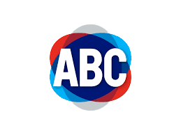

Lets first understand what was the requirements that needed to be implemented with the help of wire frames.

## Understanding Design

This is the landing page of the website which have **navigation bar** which is common in all the pages. **Footer** is also another component which is common in all pages.

The benefits section and the courses are displayed in the form of **cards**. The container needs to be responsive to different screen sizes.

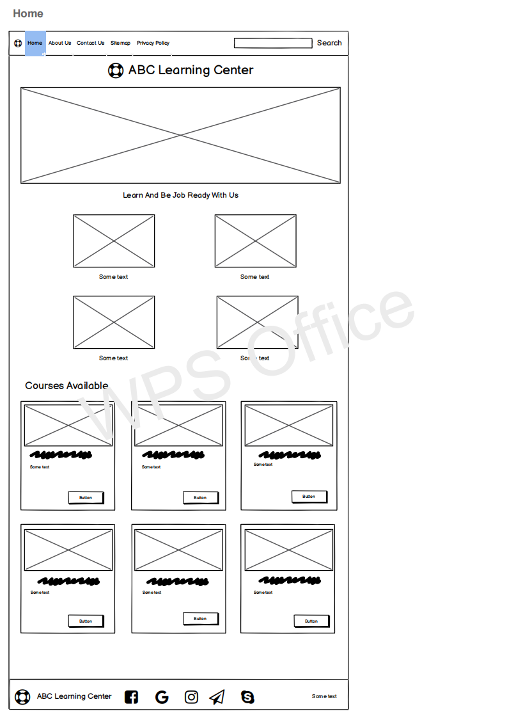

|  |  |  |
| --- | --- | --- |
| Design Requirements | Implementation | Implemented/Variance |
| Responsive Navigation Bar | I used HTML anchor tag to structure the navigation bar and CSS to make it responsive. When the screen width is small to display all links, navbar hides all the links in a **menu** style. | It is common among most of the website as it is commonly used. |
| Responsive Footer | With the help of HTML and CSS I developed responsive footer which maintains its flow along with the screen width. | It is common in website. |
| Schedule Page | The schedule page displays the course topics covered divided in weeks. The user can decide if he can enroll in the course as he will be aware of the time spend in the course. | Most of websites don’t allow the user to see this page before registration and enrollment in the course |
| Tabs | The tabs are implemented with the help of JQuery, HTML, CSS. JQuery UI provides the tab functionality which is easy to implement. This helps to break the information in small sections. | Generally learning websites implement scroll functionality which enables user to get all the data with scrolling. This makes the information at the bottom hard to reach and site can be slow as large amount of data needs to be loaded. |
| Drop down menu | This is feature which enables user to click on a button and a list of links are displayed to the user. This is implemented with vanilla JavaScript, CSS and HTML. | This is a rare feature in the learning website. Most website display all the links at once. |
| Dark Mode | The button is designed in CSS and the functionality is done with JavaScript. The preferred theme of the user is saved so that user can have his preferred theme when he revisits the website. | Dark mode is a feature which is now gaining popularity and many websites are implementing it. |
| Back Button | This again a vanilla JavaScript functionality which allows users to get to the last page they accessed during one session. This results in great user experience | Most of the websites don’t implement this feature. |

# Quality Assurance

## Intro

Quality assurance(QA) brings unique value and ensures that the product meets the requirements. It is the process that focuses on identifying and maintaining requirements for products or services. It increases credibility, boosts customers confidence, improves workflow efficiency and gives you a competitive advantage.

International Organization for Standardization (ISO) is the driving force behind QA. Companies use this standards to ensure that their QA system is effective.

**Quality Attribute Approach**

It concentrates on six quality characteristics :- **Functionality, Reliability, Usability, Efficiency, Maintainability, Portability.**

## PDCA

PDCA stands for plan-do-check-act. It is a methodology used in QA.

**Plan-** In this stage you gather requirements and create a solid plan for the development or improvement in your product.

I planned to first understand the objective and goals of the project with the help of ABC Learning Center and gathered all the requirements for the project. Plan all the steps for designing and developing the project along with tests. This is the brief of a more detailed plan.

1. Understand goals and expectations of ABC Learning Center
2. User requirements and market research
3. Decision of pages and tech stack
4. Design Documents
5. Development
6. Testing
7. Deployment

**Do-** Development and testing comes here.

I followed the plan and started by creating wire-frames, information architecture and storyboard. Get reviews from the client and improve it. After finalizing version, development and testing will start.

**Check-** Get feedback from users or internal team members and check whether it meets the objectives.

I will review all the test cases so that the output is as excepted and in line with the objective. Get reviews from the clients and analyse the reviews for further actions.

**Act-** Implement actions and next steps based on the reviews and repeat the whole cycle again for improvement.

Based on the reviews received, I will plan the improvements for the project and repeat the cycle to achieve the best version of the project.

## Tabular view

|  |  |  |  |
| --- | --- | --- | --- |
| **No.** | **Stage** | **QA Techniques** | **Implementations** |
| 1 | Understanding Goals | Here you have understand and define the goals and objectives of the clients. This ensures that your developed product matches the expectations of the client. | I held a meeting with client for understanding their expectations and goals. Documented the objectives and goals. |
| 2 | Requirements gathering | Gather all the requirements that will be needed for developing the project. Analyse the gathered requirements along with studying the market. | Based on goals, I analyzed the user requirements and studied the market and ABC Learning Center competitors. |
| 3 | Planning | After you have a well defined goal and all the requirements gathered, plan a solid strategy for developing the project. Create suitable schedule for providing deliverable and track the progress with documentations. | I planed the actions that are needed to be taken in a sequential order based on priority. |
| 4 | Designing | Design the website interface, create and finalize the logo, brand colors, designs, UI/UX with documents and communicate with the clients. | Create the logo, finalized brand colors, typography and designs. Developed the wire-frames, information architecture and storyboard following proper documentations. |
| 5 | Development | After the design stage is completed, start with the development and coding the web pages as planned along with proper technical documentations for maintainability and readability. | Developed the web page and components according to the plan along with unit testing and proper documentations. |
| 6 | Testing | Test all the web pages and component individually as well as perform integration test. Analyse the test results and get feedback from the client and if possible release beta version for analysis. | Created test cases and tried to pass all the test. Analyzed the results and made required improvements. |
| 7 | Deployment | This is the last stage of the process which should be done after the website is completed and tested thoroughly. Deploy your website to a hosting service provider. | Deployed the site on the Apache HTTP server on windows machine. |

# Technical Challenges

## Intro

Every developer faces technical challenges while developing projects. Overcoming the challenges helps the developer to grow and he learns new skills and techniques by making new projects. This also one of the most effective way to learn a new programming language or technology.

## Challenges I Faced

1. Navigation Bar

In the start I used bootstrap navigation bar, but it I wanted to customize it which made the navbar to misbehave and at the end I have to drop the bootstrap navbar and create my own implementation.

Even though bootstrap is simple to use, there are many reasons to not use such as all the sites using bootstrap ends up looking similar, you load code which you don’t even use in your website resulting in slow performance.

This the first bootstrap navbar

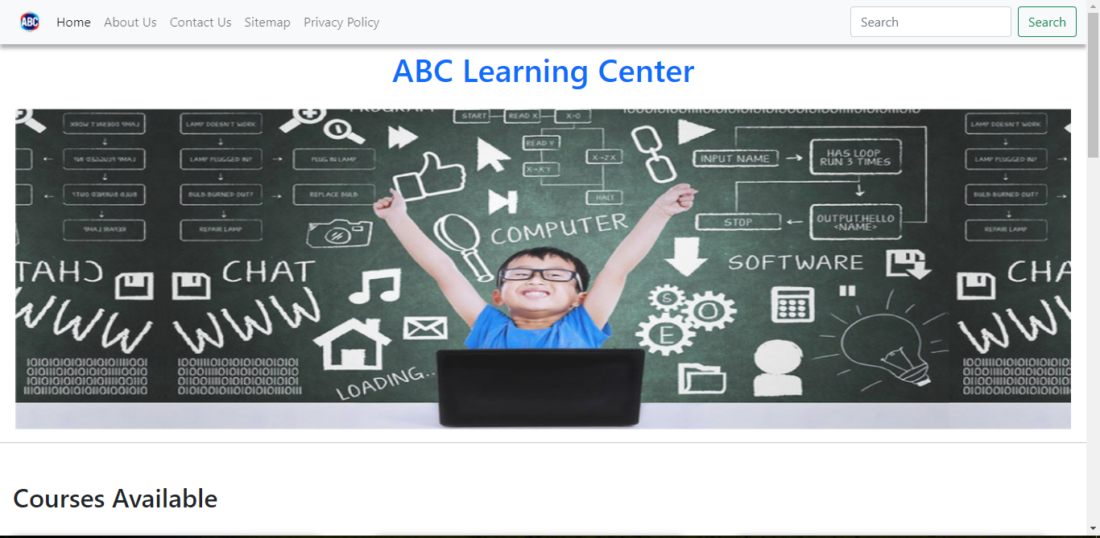

This is my own implementation inspired by the bootstrap navbar

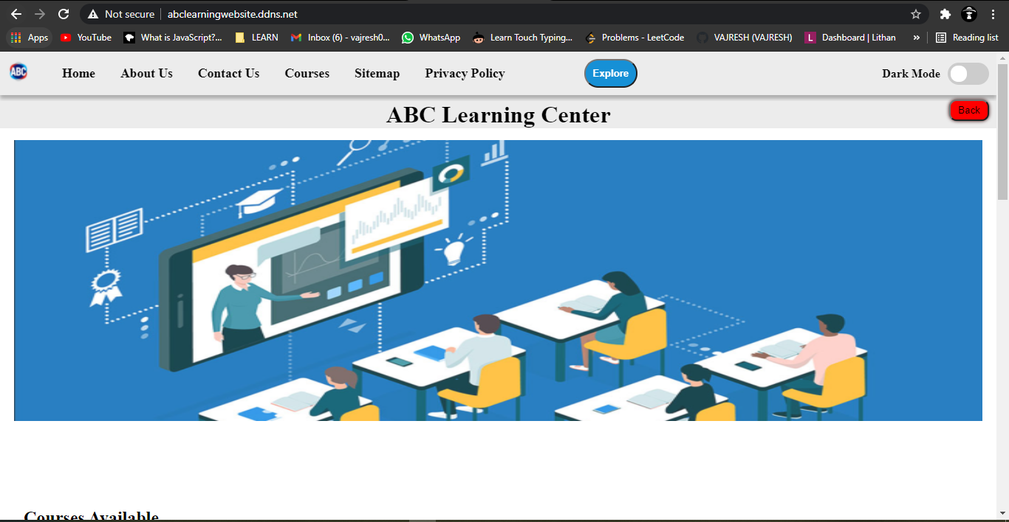

1. Drop-down menu

Developing the drop down menu with Jquery UI was very challenging. When I implemented the drop down for the first time, it didn’t work and the code was not implemented and it took a while to realize that I included work CDN link. This was my first challenge.

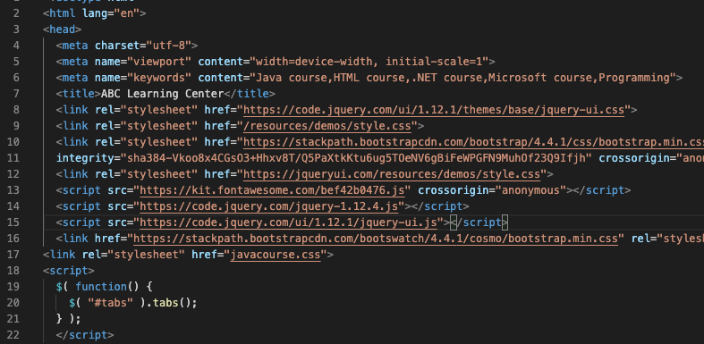

After that issue was resolve, my next ordeal was customization which didn’t go as planned as JQuery implements their styles directly in HTML style attribute which gives it higher preference and my style won’t override it. So I implemented the drop down menu with HTML, CSS and vanilla JavaScript. Custom implementation went smoothly. Here is the outcome of the custom implementation.



1. Registration form design

The form design I implemented was not pretty straight forward and too harsh on the eyes with bright colors. My client suggested to change the design and with some tweaks the form design is now much better and the error message are also neat.

Here is previous design

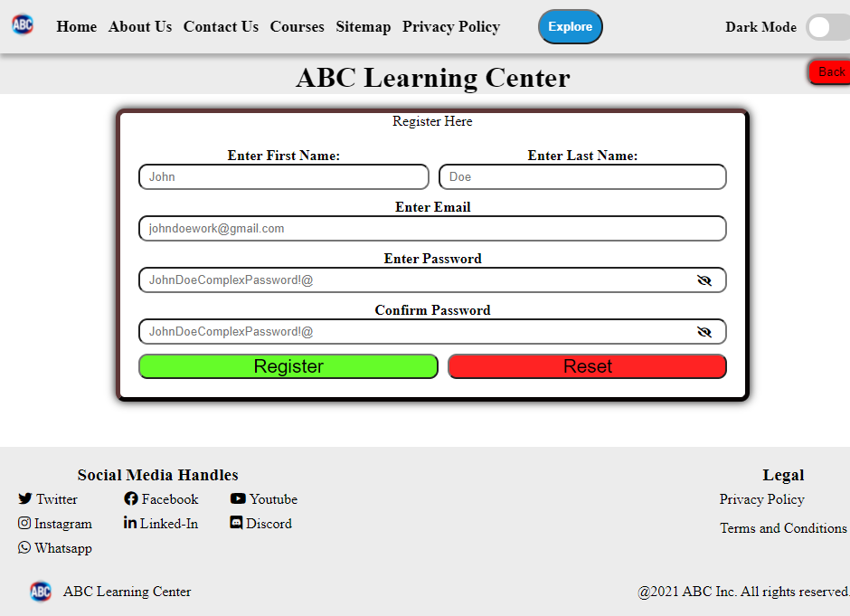

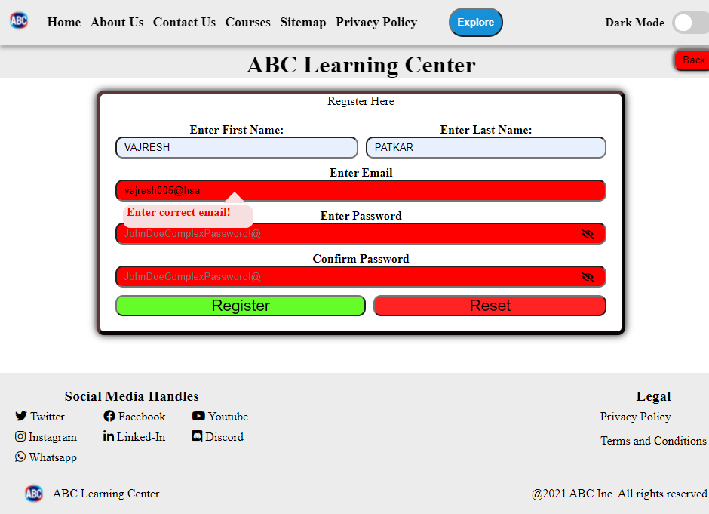

Here is the current design implementation





1. Writing Responsive Sections

The course card container was very challenging to implement. The first implementation to make the container responsive was to make the CSS display property to grid and write media queries to adapt to the changes in the screen. It was responsive, but too much code was to be written for just one feature and it also made the maintainability and testing harder and the cards were not responsive.

This is what is looked like with display set to grid in large screen and small screen

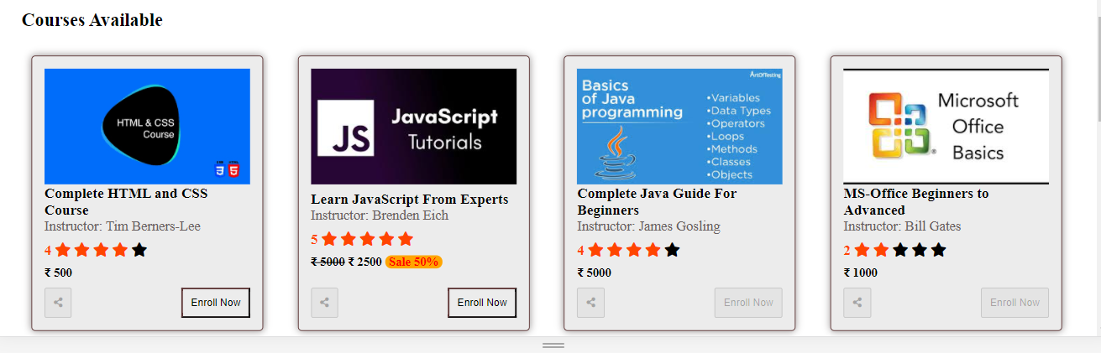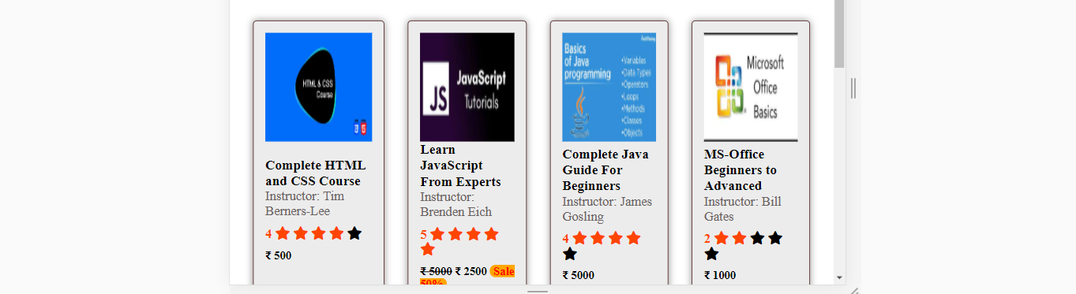

After changing the display property to flex and made other grid related changes this is the outcome on the small screen which is great.



# Test Reviews

## Intro

Testing any software product ensures that it has less bugs and it saves time in the long run. Website needs to be tested in many fronts such as testing about security, performance, SEO friendliness, best practices, integration, interactivity and functionality, cross browser compatibility, etc. There are many tools and techniques that helps you to test your website and identify any potential bugs.

A way to test websites is using tools for testing. There are markup validation tools which check for HTML pages. They test your HTML page to have semantic structure, follow best practices. One of the example is w3c markup validator. It takes HTML file and display any errors and warnings.

## Passed Test Cases

For more passed test cases and details please read the section **Website Testing**, there I have discussed about passed test more in depth. Here I will be **focusing** more on the test that I **failed** or just barely passed and needs **improvements**

Here are screenshot of the some of the tools that I used to test website and passed the test.

W3c Markup validator for testing HTML files to follow semantic structure, best practices, invalid syntax.



W3c CSS Validator for testing CSS files for any invalid CSS.



Google Lighthouse test to check SEO friendliness of the website.



Responsiveness of the header to adapt to different screen sizes.

Desktop Screen:



Mobile Screen:



## Rectifications

**Screenshot No 1:** Cross Browser Compatibility

The website was not compatible in fire-fox but after adding suitable CSS it became compatible to fire-fox.

Before:

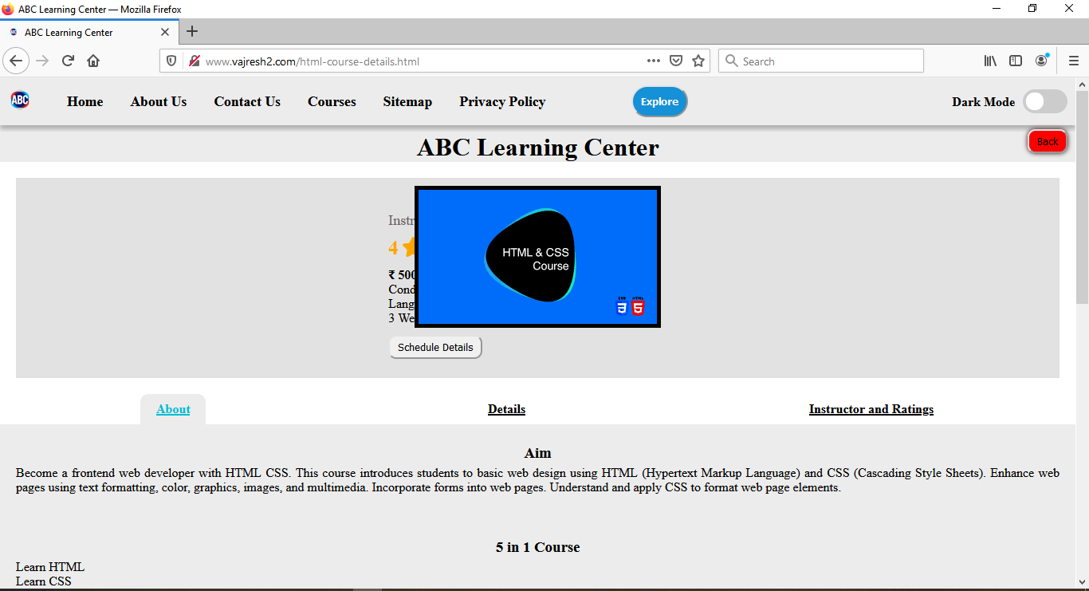

After:

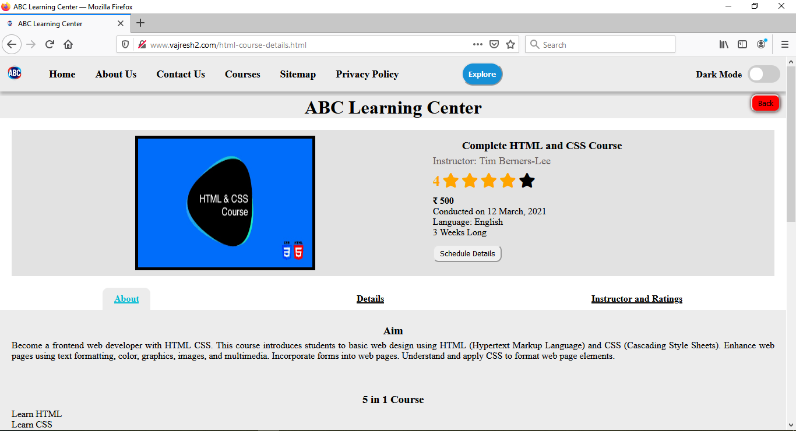

**Screenshot No 2:** Screen reader accessibility

Website was not accessible to screen readers before

Before:

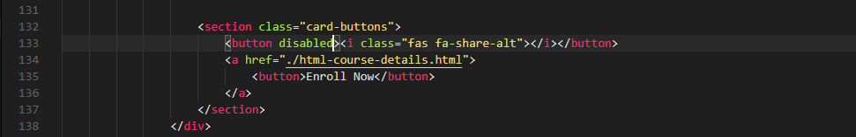

After:

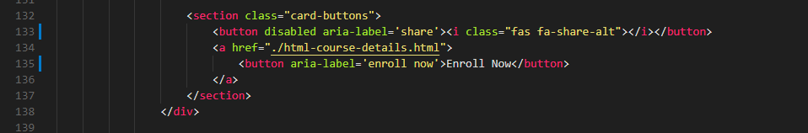

**How will this help?**

This rectification will enable your website to reach a wide range of audience. In the first test, we were able to make the website able to be accessed from any browser user want. This increases the chances of reaching more users with different browsers. In the second test, we ensured that website is accessible to screen readers which means disabled users can also uses your website.

|  |  |  |  |  |  |
| --- | --- | --- | --- | --- | --- |
| **Id** | **Test Case** | **Expectation** | **Actual Result** | **Pass/Fail** | **Rectification** |
| **1** | Cross browser compatibility | Website should be compatible in fire-fox | Some CSS styles were broken in fire-fox | Fail (Refer screenshot 1) | Added fire-fox specific CSS properties which starts with -moz. This fixed the website and made it compatible in fire-fox |
| **2** | Screen reader accessibility | Screen reader should be able to read the websites | Some buttons were not read by screen reader | Fail (Refer screenshot 2) | Adding aria-label to the buttons solved the problem. |

## Improvements

**Screenshot No 1:** Best practices

Google Lighthouse test that shows 87% best practices are followed.



**Screenshot No 2:** Accessibility

Google Lighthouse test that calculate that the website has only 61% accessibility.

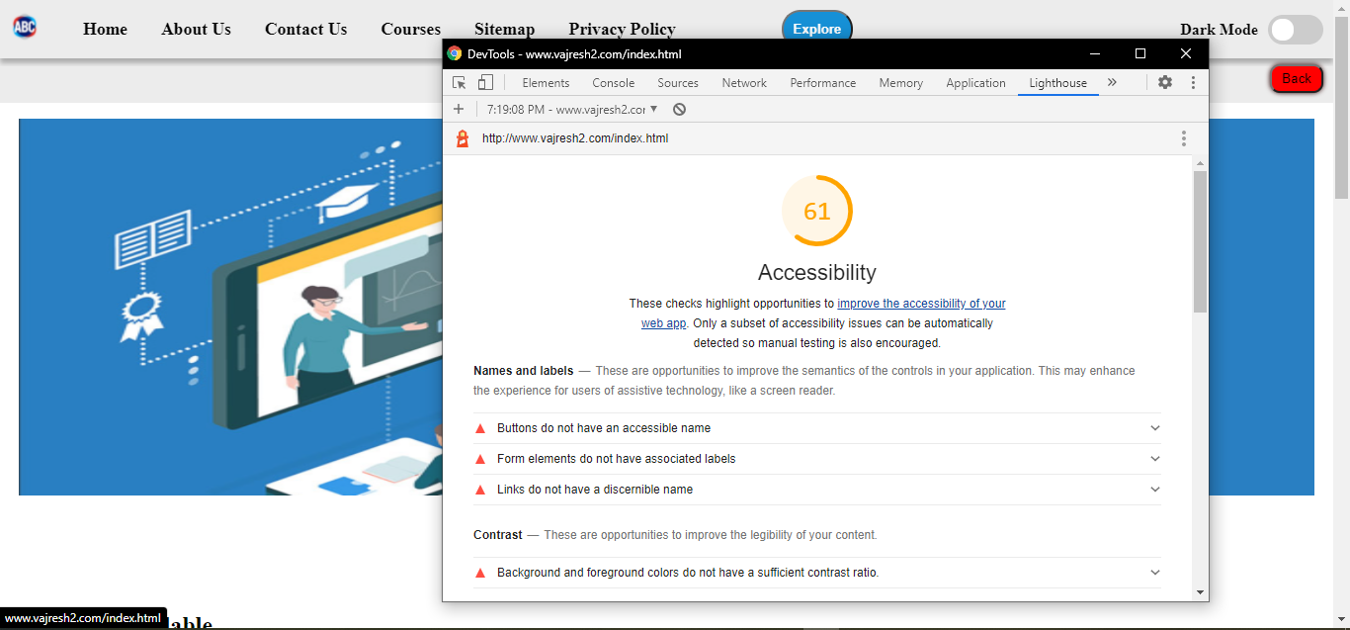

**Screenshot No 3:** Performance

Google Lighthouse test shows the website performance is 26%.

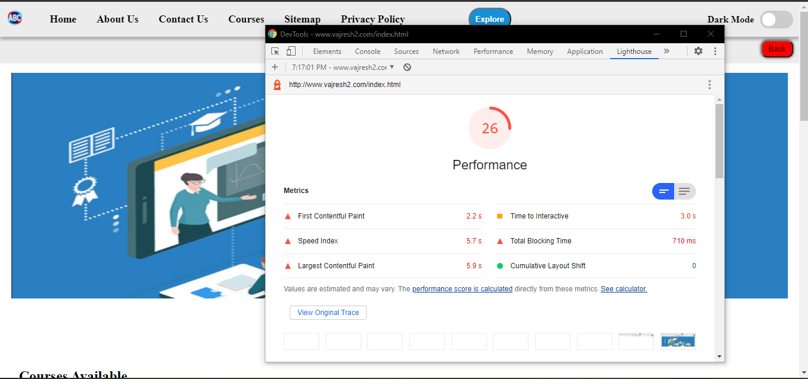

**Screenshot No 4:** Form Data

Form data is send to the back end but the file that should receive data is not found by the front end. Hence a 404 error is seen.

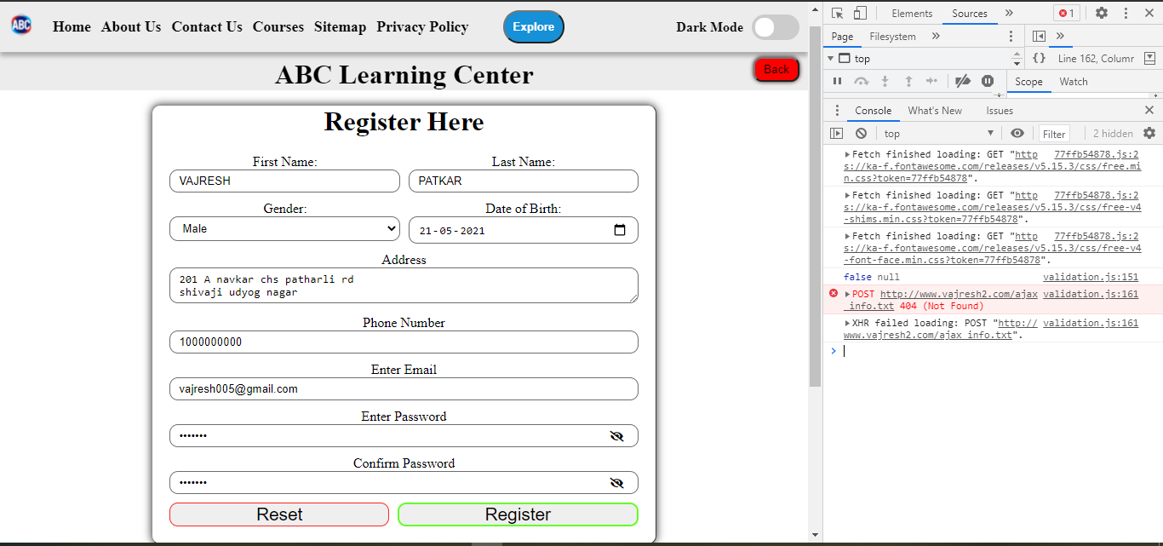

## Tabular View

|  |  |  |  |  |  |
| --- | --- | --- | --- | --- | --- |
| **Id** | **Test Case** | **Expectation** | **Actual Result** | **Pass/Fail** | **Improvements** |
| 1 | Best practices test to be followed in the website | Score above 80 | Score is 87% (Refer to screenshot 1) | Pass | Can be improved to 100%. There are suggestions in the google lighthouse. Aspect ratio of the images needs to be maintained and low resolution images needs to be served to improve speed. |
| 2 | Accessibility test to enable the usage of website by disabled people. | Score above 90% | Score is 61% (Refer to screenshot 2) | Fail | Google Lighthouse suggests to improve keyboard navigation and to add color contrast. |
| 3 | Performance of the website. | Score above 90% | Score is 26% (Refer to screenshot 3) | Fail | Improvements can be done by caching the static pages, reduce serving unused JavaScript and CSS. Cache and reduce the size of the images. |
| 4 | Form Data should be saved in the back end at a file. | Data is saved in the file | File is not found by the client and 404 error is received (Refer to screenshot 4) | Fail | Configure the back end. Check whether the AJAX request is correct and change if anything is wrong. |

# Bibliography

Cloudflare [WWW] What is DNS? [online] Available at: <https://www.cloudflare.com/en-in/learning/dns/what-is-dns/> [Accessed: 1 May 2021]

Usability.gov [WWW] Method and requirements for project planning [online] Available at: [https://www.usability.gov/how-to-and-tools/methods/requirements.html](https://www.usability.gov/how-to-and-tools/methods/requirements.html#:~:text=Website%20requirements%20are%20a%20list,and%20prioritize%20the%20project%20plan.) [Accessed: 20 May 2021]

Storyboard Artists [WWW] What are story boards used for? [online] Available at: <https://storyboardartists.com/what-are-storyboards-used-for/> [Accessed: 20 May 2021]

Dyno mapper [WWW] Website development planning process [online] Available at: <https://dynomapper.com/blog/487-website-development-planning-process> [Accessed: 21 May 2021]

W3.org [WWW] Markup validator [online] Available at: <http://validator.w3.org/> [Accessed: 21 May 2021]

W3.org [WWW] CSS validator [online] Available at: <http://jigsaw.w3.org/css-validator/validator> [Accessed: 21 May 2021]

Concise Software [WWW] Beginners guide to software development [online] Available at: <https://medium.com/@concisesoftware/everything-you-should-know-about-qa-in-software-development-the-beginners-guide-3e7afacf607c> [Accessed: 21 May 2021]